Exhibit No.:

Issues: Normal Billing Units
Witness: Henry E. Warren
Sponsoring Party: MoPSC Staff
Type of Exhibit: Direct Testimony
Case No.: GR-2002-356
Date Testimony Prepared: June 20, 2002

MISSOURI PUBLIC SERVICE COMMISSION
UTILITY OPERATIONS DIVISION

direct TESTIMONY

OF

HENRY E. WARREN
LACLEDE GAS COMPANY
CASE NO. GR-2002-356

Jefferson City, Missouri
June, 2002
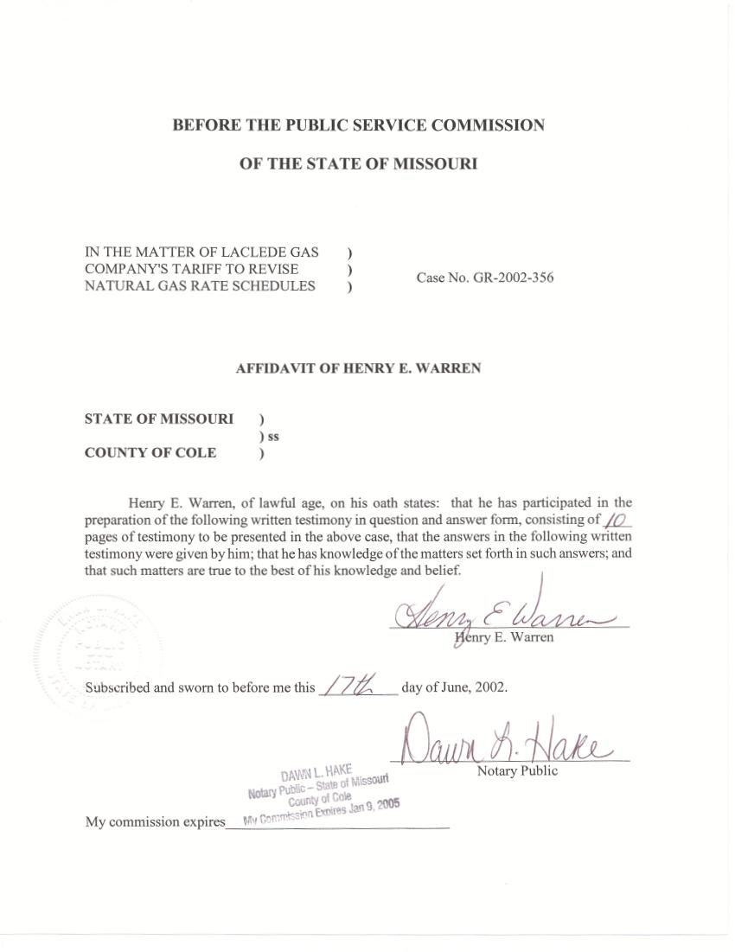

TABLE OF CONTENTS

ADJUSTMENT TO TEST-YEAR THERMS FOR WATER-HEATING 3
GENERAL SERVICE BILLING DETERMINANTS 7

DIRECT TESTIMONY
OF
HENRY E. WARREN
LACLEDE GAS COMPANY
CASE NO. GR-2002-356

Q. Please state your name and business address.
A. My name is Henry E. Warren and my business address is P. O. Box 360, Jefferson City, Missouri, 65102.
Q. By whom are you employed and in what capacity?
A. I am employed by the Missouri Public Service Commission (PSC or Commission) as a Regulatory Economist in the Energy Department of the Utility Operations Division.
Q. How long have you been employed by the Commission?
A. I have worked at the Commission nine years.
Q. What is your educational and professional background?
A. I received my Bachelor of Arts and my Master of Arts in Economics from the University of Missouri-Columbia, and a Doctor of Philosophy (PhD) in Economics from Texas A&M University. Prior to joining the PSC Staff (Staff), I was an Economist with the U.S. National Oceanic and Atmospheric Administration (NOAA). At NOAA I conducted research on the economic impact of climate and weather. I began my employment at the Commission on October 1, 1992 as a Research Economist in the Economic Analysis Department. My duties consisted of calculating adjustments to test-year energy use based on test-year weather and normal weather, and I also assisted in the review of Electric Resource Plans for investor owned utilities in Missouri. From December 1, 1997, until May 2001, I was a Regulatory Economist II in the Tariffs/Rate Design Section of the Commission’s Gas Department where my duties still included analysis of issues in natural gas rate cases and were expanded to include reviewing tariff filings, applications and various other matters relating to jurisdictional gas utilities in Missouri. On June 1, 2001 the Commission organized an Energy Department and I was assigned to this Department in the Tariff/Rate Design Section. My duties in the Energy Department are similar to my duties in the Gas Department.
Q. Are you a member of any professional organizations?
A. Yes. I am a member of the International Association for Energy Economics and the Western Economics Association.
Q. Have you previously filed testimony before the Commission?
A. Yes. I have filed testimony in the cases listed in Schedule 1 attached to this testimony.
Q. What is the purpose of your direct testimony?
A. My direct testimony covers two areas. The first is the adjustment of test-year therms for gas water-heating use. The inputs and results of the regression and this procedure are shown in Schedule 2-1 for residential customers and Schedule 2-2 for commercial general service customers.
Second, I did the billing unit allocation for adjustments to test-year therms for Laclede's general service rate classes computed by Staff Witnesses Mr. James Gray and Ms. Kim Elvington, PSC Energy Department, based on the difference between test-year and normal weather. The monthly, test-year therms, computed adjustments allocated to the rate blocks, and the final results of this adjustment for weather are shown on Schedule 3-1 for the Laclede Division; Schedule 3-2 for the Missouri Natural and Franklin County Divisions combined; Schedule 3-3, for the Midwest Division; and Schedule 3-4 for the St. Charles Division.

ADJUSTMENT TO TEST-YEAR THERMS FOR WATER-HEATING

Q. Why do you attempt to account for seasonal differences in the use of gas for water-heating in the adjustment procedure for weather?
A. Because in the Commission’s Report and Order in Case No. GR-92-165 the Commission approved and adopted the Stipulation and Agreement in which the Company agreed to work with Staff to determine appropriate procedures for estimating and normalizing monthly water heating use. In the Company’s 1990-91 NAF Study (Normalization Adjustment Factor) the Company presented a relationship between intake water temperature and therms used for water heating. This study was conducted by the Company and provided to the Staff previously. This study estimated the gas required to heat a gallon of water in the non-heating season compared to the gas required to heat a gallon of water in the heating season. The Company identified a subset of residential and commercial customers through a process of screening monthly, seasonal and annual customer bills. This process had the goal of identifying customers that use gas for water-heating but not for space heating. The Company used the monthly therms of this subset to compute its adjustment of 1.35 as the annualized differential between therms used for water-heating in the non-heating season vs. the heating season. The Company postulated that the primary determinant of the temperature of water entering the water heater is the temperature of the water at its source. For most of the service territory the source is the Missouri River.
Q. Are river water temperatures available for the Company’s Service Territory?
A. Yes. Staff Witness Mr. Dennis Patterson, PSC Energy Department, obtained daily Missouri River water temperatures since 1986 from the U.S. Army Corps of Engineers (USACE). Most of the customers located within the Company's service territory use water taken from the Missouri River. Most of the remaining customers in the service territory obtain water from the nearby Mississippi River or Meramec River. Staff assumes that the daily Missouri River water temperature is a reasonable proxy for the water in other nearby rivers and the intake temperature in water heaters in the Laclede service area.
Q. How does Staff use these daily river water temperature data in the analysis of gas use for water-heating?
A. Mr. Dennis Patterson used the daily average water temperatures (Tw) to compute a daily series of Water-heating Degree Days (WHDD) to the industry standard base temperature of 140ºF (WHDD = 140 - Tw). Mr. Patterson also estimated a set of normal WHDD. The procedures and results are presented in his testimony. These test year and normal WHDD are independent variables in models that estimate therms used for water-heating in the test year and a normal year.
Q. Has the Staff investigated methods that determine the seasonal difference in the use of gas for water-heating?
A. Yes. In a prior Laclede Rate Case (Case No. GR-92-165) Mr. Dennis Patterson presented a method different from the NAF method used by the Company. In the Commission’s Report and Order in Case No. GR-92-165, the Commission approved and adopted the Stipulation and Agreement in which the Company agreed to work with Staff to determine appropriate procedures for estimating and normalizing monthly water heating use. The Company agreed to supply data on water heating usage. Working with Mr. Patterson and Mr. Gray, I investigated and evaluated various methods for estimating water-heating use. These are the methods: 1) Laclede’s NAF method with alternatives that allow adjustments to test year usage as the result of the variation of water-heating use with water temperatures; 2) Staff’s water-heating degree day method using WHDD from the Missouri River; and 3) End-Use methods including models from both Laclede and the Gas Research Institute (GRI). The analysis and results of my evaluation are contained in the report, Evaluation of Selected Methodologies for Quantifying Gas Use for Residential and Commercial Water Heating, submitted to the Commission in November 1994, and included as Schedule 4 to my Direct Testimony.
Q. Were you able to comprehensively evaluate these various methods using the data furnished by Laclede?
A. No. The evaluation of Laclede’s residential and commercial customers’ water heating use was limited by the data supplied by Laclede. Laclede did not furnish actual end use data on water heating. The Company furnished monthly usage data on a set of residential and commercial customers selected on the basis of low use in the winter months. This screening method allegedly determined that these customers were gas water heating but not gas space heating customers; however, the Company did not verify the actual gas appliances and end use of gas by these customers.
Q. What are the results of your evaluation of these various methods?
A. The primary result of the evaluation of other studies is that there is a clear and strong correlation between water-heating use and WHDD. This has two major implications for this rate case. First, to properly estimate water-heating use for a test-year, WHDD from the test-year must be used as a basis for the estimate. Second, because water-heating degree days can vary significantly from year-to-year, test-year water-heating use should be adjusted for these variations. The data furnished by the Company corroborated this result.
Q. In this case, what method did you use to adjust the test-year usage for variations in gas use for water-heating?
A. The method I used was the same as in a previous Laclede Rate Case
(GR-94-220). This method is similar to the method developed by Mr. Dennis Patterson in Laclede Rate Case No. GR-92-165.
Q. Will you briefly describe the procedure?
A. Yes. The procedure uses coefficients estimated from data furnished by the Company from an NAF screening of customers for the period July 1992 through June 1993. I used this monthly usage data provided by the Company on residential and commercial customers to quantify a relationship between the monthly therms and the WHDD computed by Mr. Dennis Patterson using linear regression analysis. A summary of the data and results for residential customers are in Schedule 2-1, and for commercial customers in Schedule 2-2.
Q. How are these results used in the process of adjusting test-year usage?
A. Mr. Gray and Ms. Elvington used the WHDD coefficients, (0.01159, for residential and 0.04590 for commercial respectively) in calculating the weather adjustment to water heating usage for Laclede's general service customers. For each month, estimates are made of the average daily therms per customer used for water heating by using the coefficient with monthly WHDD for the test-year. Mr. Gray and Ms. Elvington subtract the estimated therms for water heating from the daily usage per customer in each month of the test-year. The remainder of the daily therms per customer for each month are adjusted for space heating usage using Heating Degree Days (HDD) as described in the testimony of Mr. Gray and Ms. Elvington.

GENERAL SERVICE BILLING DETERMINANTS

Q. What are the billing determinants established for the general service class by the current rate design and how are Mr. Gray’s and Ms. Elvington’s usage adjustments for weather allocated according to these billing determinants?
A. The three General Service (GS) class rates are differentiated into two blocks and two seasons. The first block for the residential class contains usage from
0 – 65 therms per billing cycle and the second block contains all usage over 65 therms per month. The first block for the commercial and industrial classes contains usage from 0 - 100 therms per billing cycle and the second block contains all usage over 100 therms per month. The two seasons are the heating season, November through April and the non-heating season, May through October. In order for Staff Witness Mr. John Cassidy, PSC Accounting Department, to compute the revenues associated with the weather adjusted therms, these therms must be properly allocated to the block and season to determine the rate at which they would be billed.
Q. What data are used to compute these billing determinants?
A. The Company provided Staff with test year billed therms by rate block for GS customer classes and rate codes. I used the Company's blocked therms (December 2000 – November 2001) to determine the percentage of usage falling into each rate block for each month. Because the rates are the same for all divisions, the monthly data were aggregated over the divisions for the GS rate codes -- residential, commercial, and industrial.
Q. How did you use that data to determine normal billing determinants for the test-year?
A. For each customer class the monthly bill frequency data and the percent of use in the initial block is highly correlated with the monthly average use per customer per day. I used regression analysis to estimate an equation that quantified the relationship between the percentage of use in a given block in a month and the average use per customer per month. I used this equation to allocate normal therms, computed by Mr. Gray and Ms. Elvington, to rate blocks in each month. Estimated normal usage per customer in each of the four divisions, computed by Mr. Gray and Ms. Elvington, was used as the independent variable in the estimated regression equations to estimate normal usage in the initial block. This equation was applied to each Laclede division separately because the monthly use per customer varies between divisions. The difference between the predicted normal initial block therms and predicted actual first block therms gives an estimated adjustment for each month for the first block, and the adjustment in the second block is set equal to the total therm adjustment minus the initial block therm adjustment.
The block adjustments are restricted in each month so the individual block adjustments cannot have different signs than the total adjustment. If a block adjustment initially has a sign different than the total adjustment, the adjustment to the therms in the first block is set to zero. The second block is then equal to the total adjustment. The allocations of monthly adjusted test-year therms to the blocks for the GS customer classes are in the Tables in Schedule 3-1 for the Laclede Division, Schedule 3-2 for the combined Missouri Natural Division and Franklin County Division, Schedule 3-3 for the Midwest Division, and Schedule 3-4 for the St. Charles Division. The monthly adjustments are summed Annually and Seasonally. The Seasonal totals are for the heating season (November-April) and the non-heating season (May-October). The normal blocked billing units for the GS class are obtained by adding the test-year adjustments to the test-year actual therms.
Q. Were any adjustments necessary to reconcile the Company’s test year blocked monthly therms with the monthly therms from Mr. Gray and Ms. Elvington computed from the Company’s billing cycle data in computing the billing determinants?
A. Yes. An adjustment was necessary because in some months the first block therms in Laclede’s test year blocked monthly therms were greater than the total therms reported in their billing cycle data. The bill frequency data in the first block were adjusted back to the total reported therms for the month in the billing cycle data.
Q. What is the Staff's recommendation for weather adjusted gas usage for the GS residential, commercial, and industrial customer classes?
A. Adjustments to therms in each billing month of the test-year appear in Schedule 3-1 through 3-4. These monthly adjustments are computed for each block in each customer class. The sum of all adjustments across all months, divisions, and customer classes is a net decrease of 30,928,268 therms. These adjustments were supplied to Mr. Cassidy for use in the revenue adjustments.
Q. Does this conclude your direct testimony?
A. Yes, it does.

