Exhibit No.:

Issues: Normal Billing Units
Witness: Henry E. Warren
Sponsoring Party: MoPSC Staff
Type of Exhibit: Rebuttal Testimony
Case No.: GR-2002-356
Date Testimony Prepared: August 2, 2002

MISSOURI PUBLIC SERVICE COMMISSION
Utility Operations DIVISION

REBUTTAL TESTIMONY

OF

HENRY E. WARREN
LACLEDE GAS COMPANY
CASE NO. GR-2002-356

Jefferson City, Missouri
August, 2002

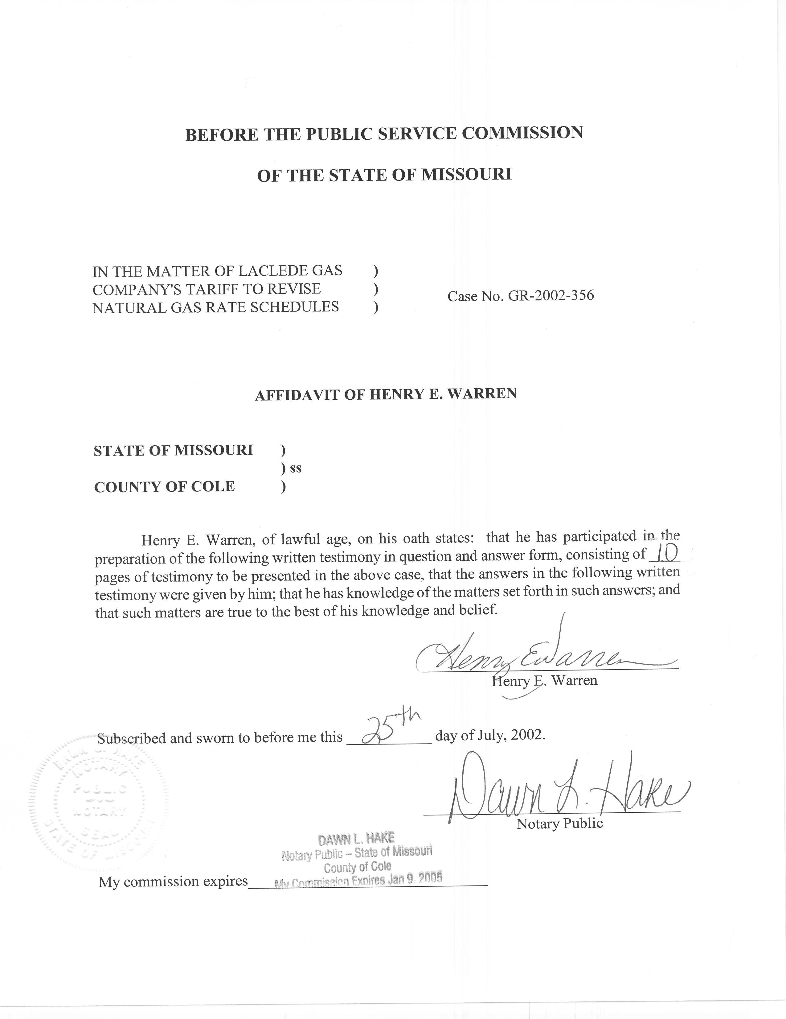

Rebuttal Testimony

Of

Henry E. Warren

Laclede Gas Company

Case No. GR-2002-356

Q. Please state your name and business address.
A. My name is Henry E. Warren and my business address is P. O. Box 360, Jefferson City, Missouri.
Q. By whom are you employed and in what capacity?
A. I am employed by the Missouri Public Service Commission (PSC or Commission) as a Regulatory Economist in the Gas Department of the Utility Operations Division.
Q. Are you the same Henry E. Warren that filed direct testimony in Case No. GR-2002-356?
A. Yes, I am.
Q. What is the purpose of your rebuttal testimony?
A. First, I will address the direct testimony of Company Witness Patricia A. Krieger on the topic of Weather Normalization. I will next address the direct testimony of Company Witness Glenn W. Buck on his topic of Customer Weatherization Program.
Q. Do you agree with Ms. Krieger’s testimony on Weather Normalization?
A. No. I disagree with Ms. Krieger’s claims as to the saturation of gas space heating among customers served by Laclede. On page 8 lines 18 – 20 she states: “Laclede’s percentage is among the highest of Utilities in Missouri and near the top of major utilities in the nation. Approximately 98% of Laclede’s residential customers use gas for their primary heat source.”
In response to a data request for information on Laclede’s claims of space heating saturation, however, I received two numbers, which were documented by a ten-year old study. No information was furnished to indicate how Laclede updates its classification of residential customers or to show what information Laclede has about other natural gas utilities in Missouri or in the U.S. Based on the lack of information, it appears Laclede does not have current surveys on customers' actual end uses of gas or the profile of the age of its customers' space heating and water heating equipment.
Q. In Ms. Krieger’s direct testimony on page 18 line 19 - page 20 line 8, she states:
This use per customer is based upon the July and August use per customer. The months of July and August do not reflect any space-heating load. This two-month use is multiplied by six to produce an annual figure, and the product of this multiplication is finally multiplied by a factor of 1.35 (135%) to calculate the annual usage which does not vary with temperature. It is necessary to increase the 12 months of summer usage by 35% to reflect the fact that customers’ “base” usage in winter months exceeds their usage during the summer. This increase is separate from any space-heating requirement and is not a function of the number of degree days experienced. Rather, it arises in large part from the necessity of heating water from lower starting temperatures during the winter. The seasonal increase in water heating load has been supported over the years by special studies of Laclede customers wherein monthly use has been analyzed and patterned.
Do you agree with the method Ms. Krieger uses to attempt to determine the average customer’s normal gas use for water heating?
A. No. In response to a data request asking for the basis of this calculation, I was sent some analysis performed in 1991. The analysis is based on unverified customer classifications according to their use of gas for space heating and water heating. The analysis refers to a 1976 Pilot Light Survey. This analysis has little validity because it is based on out-of-date data that does not consider any technological upgrades of customers’ appliances in ten years or more. Also, the process used to identify Laclede's space-heating customers from its water-heating only customers appears imprecise.
Schedule 2-A was prepared using pages from a data request response from Laclede and it contains Laclede Gas Company, NAF Study Based on 12 Months Ended June 1991. In Schedule 2-A, the number of non-space-heating, water-heating customers in the Laclede Division is estimated as 995 (Column 2 (In Sample), row 1 (Laclede).
Schedule 2-B contains Laclede Gas Company, NAF Study Based on 12 Months Ended June, 1993, Based on Accounts Used in Previous Study with all the criteria. In Schedule 2-B the number of non-space-heating, water-heating customers in the Laclede Division from the first study still identified by the screening method as non-space-heating, water-heating customers is 458 (Column 2 (In Sample), row 1 (Laclede). This is a decrease of over 50%.
Schedule 2-C contains Laclede Gas Company, NAF Study Based on 12 Months Ended June, 1993. In Schedule 2-C in 1993 the number of non-space-heating, water-heating customers in the Laclede Division identified by the screening method as non-space-heating, water heating customers is 807 (Column 2 (In Sample), row 1 (Laclede). This is an increase of 349 or 76%.
It seems unlikely that a turnover rate of over 50% in a two year period would occur among this small group of special customers. Consequently, the results of the analysis based on these data are not only outdated but in need of verification.
Q. Ms. Krieger multiplies the therms used in two summer months, July and August, of the test year, by 8.1 (= 6 x 1.35) to estimate the 12-month usage adjustment to test year water heating therms. Is this a statistical estimator of annual water heating usage?
A. No, this is a point estimate. This method is not valid because it assumes a constant ratio between water heating in July and August of the test year and total water heating use for the entire test year. Because the ratio is not constant, this method does not accurately measure water heating use in the test year or normal annual water heating use.
Q. How do you know that the ratio is not constant?
A. The Company conducted a study in 1991 in which monthly estimated therms for water heating are related to water temperatures at the St. Louis County Water plant. For that year, the estimated difference between the test period of July and August annualized (2 months multiplied by 6 = 12 months) and the total for the year was estimated to be 1.35. However, due to variations in summer temperatures and winter temperatures this relationship is not constant.
Q. Do you have any other concerns with Ms. Krieger's analysis?
A. Yes. Ms. Krieger's method assumes an average hot water use per customer that is above values found in end-use studies by both the Gas Research Institute (GRI) and the U.S. Department of Energy (DOE). GRI and DOE conducted end-use studies where they observed typical households and the amounts of gas used for specific purposes such as water heating, space heating, cooking, etc. This is documented in the 1994 Report, Evaluation of Selected Methodologies for Quantifying Gas Use for Residential and Commercial Water Heating, (Warren, 1994) (1994 Report). This Report is attached to my direct testimony as Schedule 4. In my direct testimony, I present a statistical method for estimating normal gas use for water heating based on water heating degree days (WHDD). Staff Witness Dennis Patterson defines WHDD (base 140F) in his direct testimony in this case.
Q. Would an end-use survey of Laclede’s customers give an improved estimate of water heating use by Laclede customers?
A. Yes, it would. An end-use survey would give verifiable information on the gas usage of Laclede’s customers. As was stated in my 1994 Report on page 8:
In the Laclede study monthly usage per customer (therms/month) is used rather than adjusting the reported usage to the days in the read cycles. The analysis in this report adjusts usage for any period to therms/day for consistency and comparison. The NAF (Normal Adjustment Factor) method applies the NAFH (Heating Rate NAF) ratio to all customers’ usage during the test year (April 91 – March 92) as an estimate of their non-space heating usage. This method does not make use of information on water temperature, surveys of water heating use, gas water heating saturation, gas water heater efficiency, or demographics on customers (i.e. household size or housing stock characteristics).
This method assumes that the annual use for water heating is proportional to the therms billed in the months of July, August, and September. The Laclede application of this method assumes that the proportional pattern of hot water use is constant between years (i.e. it is assumed that the NAFH ratio from the subset is applicable to all customers in subsequent years.
Q. Was the 1994 Report prepared as a result of a Commission Order (Order) dated August 21, 1992 in Case No. GR-92-165?
A. Yes, page 8 of the Order states:
“Laclede has also agreed:
(b) To provide data on water heating usage by random sampling from extreme winter and summer years, and to work with Staff to determine appropriate procedures for estimating and normalizing monthly water heating use;”
Q. Has the Company complied fully with this order?
A. No, the Company has not fully complied with the order. In Case No. GR-92-165 the Company used the same method for adjusting for non-space heating use as they have used in this case. The purpose of the Order was for Staff and the Company to participate in the development of a method for making adjustments to revenue that would be a function of test-year weather and normal weather. I have attached the related section of the Order as Schedule 1 to this rebuttal testimony.
Q. Did the Company furnish any data for the analysis you performed in the 1994 Report?
A. Yes. The Company furnished the same data discussed above, which consisted of billing data identified as water-heating customers that are not space-heating customers on the basis of their heating season and non-heating season usage patterns. As I said in the 1994 Report, an end-use study is the only way to verify any estimate of how much gas is used for a particular purpose.
Q. Did you provide copies of the 1994 Report to the Company?
A. Yes, I did.
Q. Did you receive any written comments or suggestions on the 1994 Report from the Company?
A. No, I did not.
Q. What would you recommend be done in order to fully implement the Commission’s Order?
A. As I recommended in the 1994 Report, an end-use study, by an independent entity such as GRI, within two years of this case could provide results that would be mutually useful.
Q. Would an end-use study provide other information that would make it possible to set rates that would more accurately reflect gas usage patterns by Laclede’s customers?
A. Yes. Currently, Laclede has blocked rates that allow for a higher rate for residential customers for the first 65 therms in a billing period and the first 100 therms in a billing period for commercial customers. I submitted a data request to Laclede asking for any information demonstrating that the boundaries of these blocks are consistent with current usage patterns. Laclede’s response was: “These rate blocks were included in settlements that were approved by the Missouri Public Service Commission in Case Nos. GO-78-38 and GR-99-315, respectively.” Apparently the Company has not seen any need to perform any study to verify that its residential customer usage patterns have not changed in 22 years. The mere fact that the rate blocks were established years ago does not mean that the blocks remain valid today. A study should be performed to determine customers current usage patterns.
Q. Ms. Krieger states on p. 9, lines 8-17 of her direct testimony:
In setting rates this Commission has traditionally approved an adjustment to Laclede’s test year data to account for the effects of weather through use of a measure known as heating degree days (also referred to as “degree day deficiencies” or simply “degree days”). This adjustment has traditionally been calculated through a comparison of the actual number of degree days experienced in the test year in Laclede’s service area with an historical measure of degree days considered to be normal in such area. The adjustment is designed to adjust test year operating results to levels which would have experienced had the test year contained a normal number of heating degree days.
Q. Do you agree that the Commission has specifically approved “an adjustment” of this type?
A. No. In Laclede Rate Case Nos. GR-92-165 through GR-2001-629, I am not aware of any rate case involving Laclede in which the Commission has, in any resulting order, approved any specific language or method for using heating degree days (HDD) to calculate an adjustment to Laclede’s test-year operating results. (HDD (base 65F) are defined in the direct testimony of Staff Witness Mr. Dennis Patterson in this case.)
Q. Ms. Krieger states on page 10 line 22 - page 11 line 2 of her direct testimony: “Earnings have been depressed by millions of dollars during these years, resulting in long-term earnings shortfalls from the levels justified and approved by the Commission in previous rate cases.”
Do you agree that the Commission has specifically approved the “earnings” Laclede was to receive as a result of rate cases during the years 1985-2002, shown in the table referred to by Ms. Krieger?
A. No, in Case Nos. GR-92-165 through GR-2001-629 I am not aware that the Commission has, in any resulting order, approved any specific language stating the level of earnings Laclede was to receive as a result of the rate case. Ordered rates do not guarantee earnings, rather they are designed to provide the Company an opportunity to achieve a level of earnings.
Q. Does Ms. Krieger, or any other Laclede witness in this case present a methodology that deterministically links Laclede’s annual earnings to HDD?
A. No, the link between HDD and earnings is implied, but not demonstrated. HDD may be one of many factors determining the Company’s earnings in a year. The Commission has not specified annual normal HDD in a Laclede rate case in the last ten years. Annual normal HDD have not been specified as part of a rate case settlement in the last ten years.
HDD are discussed throughout the testimony submitted by the Company in this case, however, current information on the usage patterns of the Laclede’s customers is scarce in testimony submitted by the Company. Weather affects the Company through the response of its customers to HDD for space heating and WHDD for water heating. Current information on customers’ appliances, conservation efforts, and other demographics are critical to quantifying the effect of HDD and WHDD. The methods, however, that Laclede uses to calculate adjustments to test-year volumes have not been updated in years. Point estimators with no measure of their accuracy are used rather than statistical estimators that have a measure of their accuracy. Moreover, there has been no re-evaluation of the appropriateness of the residential rate block established over twenty years ago. Rates should be set on current documented usage patterns.
The Company’s implication in its testimony in this case that the Commission has somehow affected the Company’s earnings in its treatment of HDD starts with a false premise – that the Commission has addressed HDD in its orders, ignores the current end-use patterns of its customers, and provides no deterministic link to a conclusion.
Q. Do you wish to respond to Company witness Glenn W. Buck’s testimony concerning the Customer Weatherization Program?
A. Yes, Mr. Buck sponsors an adjustment that includes, in expense, the costs of the Customer Weatherization Program implemented by Commission Order (Order) in Case No. GR-2001-629. On February 28, 2002, the Company filed tariff sheets on the Weatherization Program with the Commission. These tariff sheets were approved and became effective March 31, 2002. This tariff implemented the Weatherization Program in compliance with the Order. The Company then entered into agreements with Community Action Agencies in its service territory to perform the weatherization on the homes of low-income customers of Laclede according to criteria and an allocation formula approved by Laclede, Staff, Office of Public Counsel, and the Missouri Department of Natural Resources. Subsequently, in April 2002, the Company issued checks for the first quarter payments for the Weatherization Program to the Community Action Agencies. The Weatherization Program has been implemented and funded to date as provided for in the Commission Order. Other Missouri gas distribution companies have implemented similar weatherization programs. These other weatherization programs have been evaluated and found to be cost effective.
Q. Does this conclude your rebuttal testimony?
A. Yes, it does.

