Exhibit No.:
Issues: Low-Income Issues

Witness: Henry E. Warren
Sponsoring Party: MO PSC Staff
Type of Exhibit: Surrebuttal Testimony
Case No.: GR-2004-0209
Date Testimony Prepared: June 14, 2004

MISSOURI PUBLIC SERVICE COMMISSION

UTILITY OPERATIONS DIVISION

SURREBUTTAL TESTIMONY

OF

HENRY E. WARREN

MISSOURI GAS ENERGY

CASE NO. GR-2004-0209

Jefferson City, Missouri
June 2004
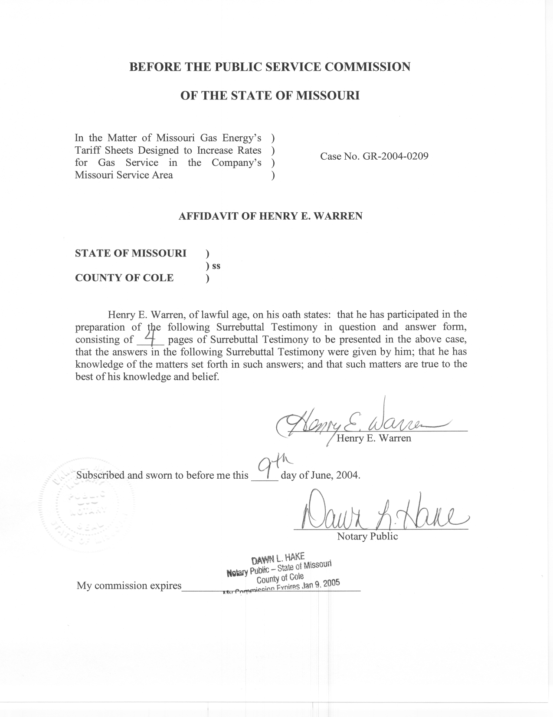

SURREBUTTAL TESTIMONY

OF

HENRY E. WARREN

MISSOURI GAS ENERGY

CASE NO. GR-2004-0209

Q. Please state your name and business address.
A. My name is Henry E. Warren and my business address is P. O. Box 360, Jefferson City, Missouri, 65102.
Q. By whom are you employed and in what capacity?
A. I am employed by the Missouri Public Service Commission (PSC or Commission) as a Regulatory Economist in the Energy Department of the Utility Operations Division.
Q. Are you the same Henry E. Warren who submitted rebuttal testimony in this case?
A. Yes, I am.
Q. What is the purpose of your surrebuttal testimony?
A. My surrebuttal testimony covers the Pay As You Save (PAYS®) system described in my Rebuttal Testimony and discusses the objections to this program contained in the Rebuttal Testimony of Missouri Gas Energy (MGE or Company) witness, Mr. Michael Noack. In his rebuttal testimony, Mr. Noack expresses two objections to the PAYS® system proposed in direct testimony by Office of Public Counsel witness, Ms. Barbara Meisenheimer. One objection is that a PAYS® system may require substantial administration and expense by the Company and the second is that any decision on a PAYS® system should be subsequent to the result of the Commission’s task force report in Case No. GW-2004-0452.
Q. Has the PAYS® system previously been described in testimony by other witnesses in this case?
A. Yes, it was discussed in direct testimony by Public Counsel witness, Ms. Meisenheimer and in my rebuttal testimony.
Q. Do you agree with Mr. Noack’s reservation that the proposed PAYS® system would require substantial expense and administration by the Company?
A. No, PAYS America, has as one of their objectives to design a PAYS® system for the benefit of the utility and its customers in the area served by a PAYS® system. Although initially a pilot PAYS® system may be offered to a limited number of customers, if the PAYS® system performs as expected, the PAYS® system could eventually be available to customers in all classes. After initial start up costs, the PAYS® system is intended to be self-supporting and should not require any company funds. The PAYS® system should also benefit the Company by making utilities more affordable to customers who currently have less efficient heating and cooling systems, and major appliances by making it possible for customers to replace older, less efficient equipment with energy efficient equipment and pay for the new equipment through savings in their utility bills. Consequently, some of the expenses in establishing and operating a PAYS® system would be covered by a revenue adder to the customer classes which would be eligible for the PAYS® system. Staff anticipates that the PAYS® system will reduce a participating customer’s utility bills and subsequently reduce excessive bills, arrearages, and the related billing, collection and disconnection expenses for the Company. The Company will provide billing for the PAYS® system, but not necessarily the financing or administration.
Q. Do you agree with Mr. Noack’s reservation that the proposed PAYS® system should be contingent on the recommendation of the Commission’s task force?
A. No, the Commission Order (Order Establishing Case and Creating Task Force, March 3, 2004) in Case No. GW-2004-0452 (Task Force) establishes a Task Force that has as one of its objectives to explore measures and programs that could have a long-term impact on the affordability of heat related bills, such as energy efficiency appliances and weatherization in homes that are not energy efficient. The objective of the Task Force is not to limit or suspend these types of programs, but is to further these types of programs. Implementing a PAYS® program is consistent with the Company’s recommendation to expand low-income customer weatherization. Even though the feasibility of the weatherization of low-income customer’s homes is one objective of the Task Force, the Company is not proposing to postpone weatherization and wait for the Task Force recommendation, but MGE is instead proposing to increase the ratepayer funded low-income weatherization program. Similarly, if a feasible PAYS® system can be developed, its implementation should not be contingent upon the Task Force recommendation, but rather a pilot PAYS® system would provide useful information for the Task Force.
Q. Is there an additional reason why the consideration of a PAYS® system should proceed in this case and not be contingent on the Task Force recommendation?
A. Yes. The focus of the Task Force is not the same as the focus of the PAYS® system. The initial focus of the Task Force is to evaluate the Commission’s Cold Weather Rule (4 CSR 240-13.055). Utility customers affected by the Cold Weather Rule are the residential class and are often are low income. A viable PAYS® system might best serve the interests of the low income residential customer by being inclusive of all customer classes and all income levels in the residential class. The PAYS® system is designed to be market based, in that it makes energy efficiency economically attractive to a wide spectrum of utility customers. The PAYS® system is also designed so that it will attract external financing; that is, the funds for financing energy efficient equipment will come from a financial institution rather than the utility or its customers. A larger pool of participating customers will likely make a PAYS® system more attractive to the external financial organizations. Thus, the scope of the Task Force and scope of the PAYS® system may have some overlap but are not coincidental.
Q. Does this conclude your surrebuttal testimony?
A. Yes, it does.

