Exhibit No.:
Issues: Rate Design
Witness: James C. Watkins
Sponsoring Party: MO PSC Staff
Type of Exhibit: Surrebuttal Testimony
Case No.: EC-2002-1
Date Testimony Prepared: June 24, 2002

MISSOURI PUBLIC SERVICE COMMISSION

Utility Operations DIVISION

SURREBUTTAL TESTIMONY

OF

James C. Watkins

UNION ELECTRIC COMPANY d/b/a

AMERENUE

CASE NO. EC-2002-1

Jefferson City, Missouri
June, 2002

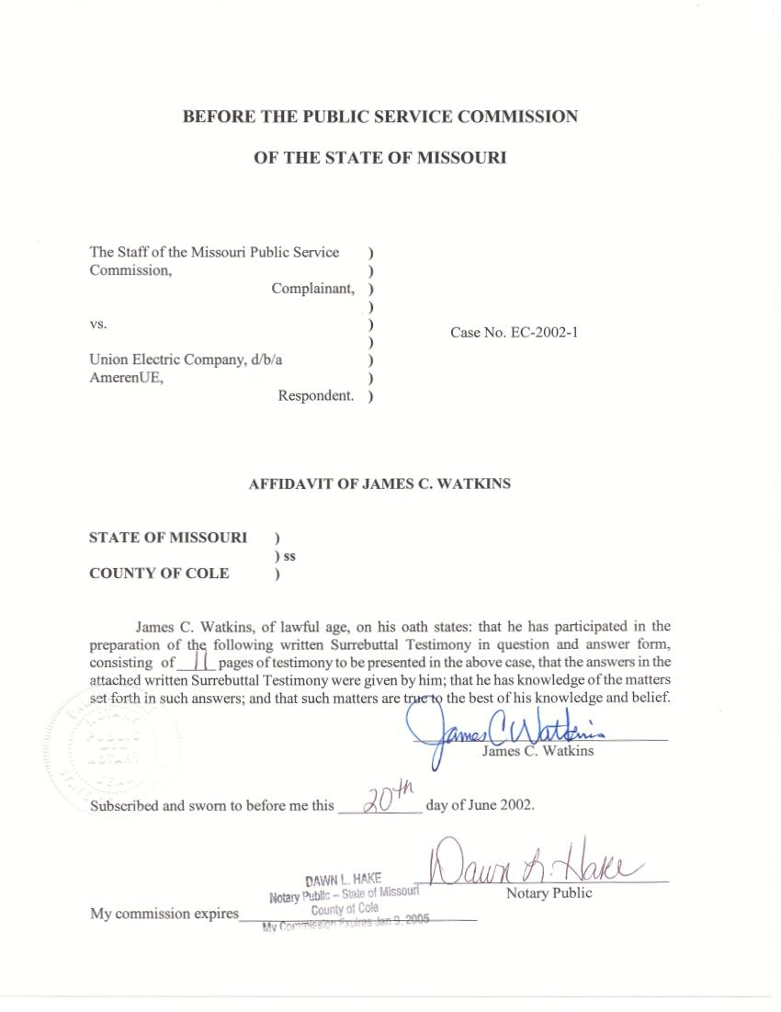

TABLE OF CONTENTS

Class Cost Of Service & Rate Design 1
Miscellaneous Tariff Issues 9
Rider E (Supplementary And Backup Service) 9
Rider RDC (Reserve Distribution Capacity) 9
Interest On Customer Deposits 10
OPC's TOU Program 11

SURREBUTTAL TESTIMONY
OF
JAMES C. WATKINS
UNION ELECTRIC COMPANY, D/B/A AMERENUE
CASE NO. EC-2002-1

Q. Please state your name and business address.
A. My name is James C. Watkins and my business address is Missouri Public Service Commission, 200 Madison Street, P. O. Box 360, Jefferson City, Missouri 65102.
Q. Are you the same James C. Watkins who previously filed direct testimony on the issue of rate design in this case on July 2, 2001 and March 1, 2002?
A. Yes, I am.
Q. What issues will you address in your surrebuttal testimony?
A. I will address the customer class cost-of-service issues raised in the rebuttal testimony of UE’s witness Mr. Richard J. Kovach, Office of Public Counsel’s (OPC) witness Ms. Hong Hu, MIEC’s witness Mr. Maurice Brubaker, and MEG’s witness Mr. Mark Drazen. I will also address the tariff proposals presented in rebuttal testimony---UE's Rider E, Rider RDC, and interest on customer deposits; and OPC's TOU program.

Class Cost Of Service & Rate Design
Q. Is there a common criticism among the above listed rebuttal witnesses regarding the Staff’s reliance on the Stipulation And Agreement incorporated in the Commission’s order in Case No. EO-96-15, UE’s most recent rate design case, and the results of the Staff’s customer class cost-of-service study filed in that case?
A. Yes. First, these witnesses point out that the Stipulation And Agreement incorporated in the order in Case No. EO-96-15 is neither binding on the parties to that agreement nor on the Commission. Second, these witnesses allege that the data the Staff and the other parties used to develop their studies in Case No. EO-96-15 is now so old that the results of those studies are no longer reliable.
Q. When you prepared your direct testimony, did you believe that the terms of the Stipulation And Agreement in Case No. EO-96-15 in any way limited the position that the Staff, the Commission or any party in this case could take on any issue in this case?
A. No. I do not believe that the parties in this case or the Commission are bound by that agreement, nor did I make that claim in my direct testimony. I did, and still do, believe that the agreed-upon resolution of the various parties’ proposals regarding each class’s revenue responsibility, or cost of service, based on the studies prepared in that case, remains reasonable.
Q. Have circumstances changed so much since the customer class cost-of-service studies were prepared in Case No. EO-96-15 to cause those studies to be unreliable for the purposes of determining a reasonable allocation of UE’s overall cost of service to the customer classes?
A. No. While there have undoubtedly been significant events that have occurred within the last few years, I am not aware of any event that has been significant in materially altering the percentage increases or decreases in each class’s revenues that would be required to match revenues to the costs allocated to each class by a customer class cost-of-service study.
It has been my experience that the basic results of a customer class cost-of-service study are primarily influenced by the choice of allocation methodologies, particularly with respect to demand-related generation plant costs, and are not significantly affected by the choice of the study period, within reasonable limits, unless major generation plant additions have been made since the last study was performed or major shifts have been made in class revenues. These types of events have not occurred since the resolution of Case No. EO-96-15.
Q. Is your experience in this regard supported by testimony prefiled in this case?
A. Yes. Mr. Kovach, UE’s witness, has filed updated class cost of service study results for UE, which he indicates are based on a twelve-month test year ended June 2001. (Kovach Rebuttal, p. 64, line 16 through p. 65, line 2). The results of that updated study are basically the same as the results of the study UE filed in Case No.
EO-96-15.
Mr. Brubaker, MIEC’s witness, has filed the results of MIEC’s class cost-of-service study filed in Case No. EO-96-15 (Brubaker, Schedule 1) and adjusts that study (Brubaker, Schedule 2) to “recognize the reduction in revenues that was allocated to the non-residential, non-lighting customer classes in that proceeding” for use of that study in this case. (Brubaker Rebuttal, p. 6, lines 11 – 14). A comparison of line 19 in his Schedule 1, to line 23 in his Schedule 2 shows that both of his studies have the same basic result. In fact, the increase or decrease in revenues required to equal cost of service for each class differs by no more than about one percentage point for any class.
Q. Has any other party presented a reasonable proposal for allocating any overall revenue reduction to the customer classes?
A. Yes. OPC’s proposal to spread the overall revenue reduction to all rate classes as an equal percentage reduction based on current class revenue is not unreasonable. Furthermore, if the Commission were to adopt the Staff’s basic rate design proposal, it would not be unreasonable for the Commission to apply a modification of the two-step approach recommended by OPC, once the remainder of the $25,000,000 of the revenue reduction contemplated in the rate design case (i.e., the first $9,834,790 of the overall revenue reduction) is distributed as recommended by the Staff. Thus, the remainder of the overall revenue reduction could be allocated between the residential class and the non-residential classes, as a group, based on an equal percentage of the adjusted revenues, then applied as an equal percentage reduction to the non-customer-charge rate components. This would result in a different percentage reduction applying to the non-customer-charge rate components of the residential class than to the non-customer-charge rate components of the non-residential classes; however, the percentage reduction applying to the non-residential classes would apply to each non-customer-charge rate component in all non-residential rate classes.
Q. Why should the same percentage reduction be applied to all non-residential rate components?
A. There are two reasons. First, this assures that the present continuity between rates is maintained. Second, this assures that the Rider B Credits, for example, remain the same for customers on the Small Primary Service rate schedule as for customers on the Large Primary Service rate schedule.
Q. Has any other party presented a proposal for allocating any overall revenue reduction to the customer classes?
A. Yes. Other than OPC, only UE and MIEC have made such proposals. I view both of those proposals to be unreasonable.
Q. Why?
A. Each of these proposals is premised on determining just and reasonable rates for each class solely on that class’s cost of service as determined by that party’s class cost of service study. The cost of service for a class is but one of a number of factors that the Commission should consider in establishing just and reasonable rates for each class of customers, and a class cost-of-service study, unlike a total company cost-of-service study, does not calculate the cost of service for each class. A class cost-of-service study merely attempts to provide a reasonable estimate of each class’s proportionate share of responsibility for UE’s total cost of jointly serving all of its customers.
Q. Do UE’s and MIEC’s studies produce reasonable results?
A. In my opinion, no. The results of those studies rest on an assumption that 100% of production capacity costs are caused by the loads in a few peak hours, with none of the costs being related to utilization of the plant to serve loads in any other hours. While this may be a traditional approach in other jurisdictions with which Mr. Brubaker is familiar (Brubaker Rebuttal, p. 5, line 20), it is an approach that has never been adopted by the Missouri Public Service Commission at any time during the past twenty years that I have been with the Staff. On the contrary, on those few occasions when cost allocations have been litigated, the Commission has always favored the Staff’s approach. The Staff’s approach, which is also favored by OPC, allocates a portion of each generation plant’s costs to every hour of the year during which that plant is being utilized to serve customers’ loads.
Q. What factors should the Commission consider in addition to an estimate of cost of service when determining the amount of UE’s revenue that should be paid in by each customer class?
A. The Commission should consider all relevant factors. These factors would certainly include fairness, affordability and the impact on customers as well as other public policy considerations.
Q. Do you have any other concerns of which the Commission should be made aware in regard to class cost of service and rate design?
A. Staff Witness Janice Pyatte is addressing the details of UE’s rate design proposal in her surrebuttal testimony; however, I want to stress that UE has presented no evidence regarding the outcome of adopting its proposals for shifting class revenue responsibilities and radically altering the way revenues are collected within the current rate structure. Aside from the possibility that residential customers may face a significant rate increase while non-residential rate classes could see rate reductions in excess of 25%, there will be significant effects within classes and between non-residential classes. One example is that UE’s proposed 56% increase to the residential customer charge will have vastly different impacts on individual customers, or groups of customers, with the greatest impact on customers with the lowest usage.
The most glaring example of the problems created between classes by UE’s proposal is between the Large General Service and the Small Primary Service rate classes. Mr. Kovach states:
The structures of these rates, which are applicable to UE’s larger commercial and industrial customers, are virtually identical, as the service provided to such customers varies only by the delivery voltage and meter location. The SPS customers receive their service, and are normally metered, ahead of any [customer-owned] transformer voltage reduction, and the LGS customers receive their service and are metered after the [UE-owned] transformer voltage reduction. (Kovach Rebuttal, p. 91,
lines 17-22).

Thus, the cost difference between these two groups is only the cost of the transformers. The current differential between these two rate schedules is still too large, even after narrowing this differential somewhat in the last rate design case. The Staff’s rate design proposal addresses this problem. Mr. Kovach acknowledges this problem;
I disagree with the first recommendation made by Mr. Watkins. However, in developing its proposed rates for the test year in this case, the Company will consider his second recommendation, regarding the proposed rate differentials between the LGS and SPS Rates as a rate design objective. (Kovach Rebuttal, p. 63, lines 4–7).

Yet, UE proposes, on a revenue-neutral basis, to reduce SPS revenues by 15.92% while reducing LGS revenues by only 5.16%. (Kovach Rebuttal, Schedule 6). This can only result in some of the LGS customers purchasing transformers and switching to the SPS rate. UE has presented no information on the expected extent or impact of this rate switching. One obvious impact is that UE would needlessly incur costs to remove its transformers when its customers purchase their own. Alternatively, if the customer seeks to purchase its transformer from UE, UE will need to obtain Commission approval to sell the transformer. As a result, each time a customer wishes to purchase its transformer from UE, the Commission will need to process another application by UE to approve the transfer of the transformer, wasting everyone’s time and resources. This is exactly what alerted the Staff that there was a problem with the rate differential in the first place.
Q. Has UE also presented testimony on another rate design proposal?
A. Yes. Mr. Kovach presents this proposal on page 110 of his prefiled rebuttal testimony. UE’s proposal is to:
. . . implement this rate reduction [associated with its proposed alternative regulation plan] on an equal percentage basis within and among rate classes (excluding customer and miscellaneous charges) for all Missouri retail electric customers.

Q. Will this proposal maintain existing rate relationships both between and within each of UE’s rate classes?
A. Mr. Kovach says, “Yes.”
Q. Is this proposal more reasonable?
A. Yes. In my view, this proposal is very similar to the proposal made by OPC. It is a reasonable alternative to the Staff’s proposal. It is certainly the antithesis of UE’s alternative proposal.
Q. Has the Staff’s recommendation regarding class revenue responsibility and rate design changed since the filing of your direct testimony?
A. No. The Staff’s recommendation was offered as a reasonable balancing of the interests of all customer classes when all relevant factors are considered. My recommendation is that the Commission adopt the Staff’s rate design proposal as presented in my direct testimony prefiled on March 1, 2002.

Miscellaneous Tariff Issues

Rider E (Supplementary And Backup Service)
Q. What is the Staff’s recommendation regarding UE’s proposed changes to its Rider E?
A. The Staff views UE’s proposed changes as a significant improvement to its current Rider E. I understand from Mr. Kovach that UE has made several modifications to its original proposal as a result of discussions during and subsequent to the prehearing conference, and that Mr. Kovach will file those changes in his surrebuttal testimony. The Staff does not oppose UE’s proposal, as modified, so long as (1) there are no unreasonable negative impacts on its existing Rider E customers, (2) the revenue effects of the changes are appropriately accounted for in the determination of UE’s revenue requirement in this case and (3) the rate values are scaled to reflect the corresponding rate values approved by the Commission in this case for the Large Primary Rate Schedule.

Rider RDC (Reserve Distribution Capacity)
Q. What is the Staff’s recommendation regarding UE’s proposed Rider RDC?
A. The Staff views UE’s proposed Rider RDC as a reasonable alternative to offer to its customers on an optional basis. The Staff does not oppose UE’s proposal, so long as the revenue effects of implementing Rider RDC are appropriately accounted for in the determination of UE’s revenue requirement in this case.

Interest On Customer Deposits
Q. What is the Staff’s recommendation regarding UE’s proposed change in the interest rate it will pay on customer deposits?
A. The Staff supports the concept of linking the interest rate applicable to customer deposits to a published market rate of interest. The Staff recommends, however, that the rate of interest applicable in each year should be one percentage point above the prime rate published in the Wall Street Journal as being in effect on the last business day of December, 2001 of the prior year, except as otherwise required by Commission rule. This approach is consistent with the Commission’s Rules regarding telephone utilities (4 CSR 240-33.050) and has been approved by the Commission for Laclede Gas Company and Citizens Electric Corporation.
Q. What interest rates would currently be in effect based on Staff’s and UE’s proposals?
A. Mr. Kovach did not report what the current rate would be; however, UE’s proposal would result in a current rate of interest on customer deposits of only 2.00%, if calculated by rounding to the nearest one-half of one percent the 2.23% yield on U.S. Treasury securities with a constant one-year maturity as reported for the week of November 30, 2001 in the Federal Reserve Statistical Release. The Staff’s proposal would currently result in a much more reasonable 5.75% rate of interest, which is one percentage point above the prime rate published in the Wall Street Journal as being in effect on the last business day of December, 2001.

OPC's TOU Program
Q. What is the Staff’s recommendation regarding the OPC’s proposed Time-Of-Use Program?
A. The Staff is very interested in participating in a program to investigate the response of customers’ demands to timely price signals. As the Staff understands OPC’s proposal, OPC is requesting that the Commission establish an Executive Committee (or, more likely, a Task Force) to investigate the design and feasibility of a possible program to study demand response. With this understanding, the Staff supports OPC’s proposal. The Staff would oppose a proposal that would limit such a project to investigating traditional time-of-day rates or mandate that the Task Force would seek only to implement a trial program similar to trial programs already implemented in other states.
Q. Does this conclude your testimony?
A. Yes, it does.

