BEFORE THE PUBLIC SERVICE COMMISSION
OF THE STATE OF MISSOURI

In the Matter of the Application of )
YMax Communications Corp. )
for a Certificate of Service Authority ) Case No. CA-2006-0373
to provide Basic Local Telecommunications )
Service in portions of the State of Missouri )
and to Classify Said Services and the )
Company as Competitive )

APPLICATION FOR CERTIFICATE OF SERVICE AUTHORITY
AND FOR COMPETITIVE CLASSIFICATION

COMES NOW YMax Communications Corp., a Delaware corporation ("Applicant" or "YMax"), by its undersigned counsel, and pursuant to sections 392.361, 392.410, 392.420, 392.430, and 392.450 RSMo., the Federal Telecommunications Act of 1996, and 4 CSR 240-2.060 and 4 CSR 240-3.510, files this verified Application requesting that the Missouri Public Service Commission (hereinafter, “the Commission”) issue and order that:
- grants Applicant certificate of service authority to provide basic local exchange telecommunications services, pursuant to Chapter 392 RSMo;

- grants competitive status to Applicant and Applicant's requested services; and

- waives certain Commission rules and statutory provisions pursuant to Sections 392.420 and 392.361 RSMo, consistent with the Commission's past treatment of other certificated providers of competitive interexchange telecommunications services.

In support of its Application, YMax states the following:
1. Applicant YMax Communications Corp. is a corporation duly organized and existing under and by virtue of the laws of the State of Delaware and is duly authorized to conduct business in the State of Missouri. Its parent company, YMax Corporation, is also a Delaware corporation. The nature of the Applicant's business is telecommunications. Pursuant to 4 CSR 240-2.060(1)(C), a Certificate of Authority to transact business in Missouri, issued by the Missouri Secretary of State, is attached hereto and incorporated herein by reference as Appendix A. Applicant's principal place of business is 223 Sunset Avenue, Suite 223, Palm Beach, Florida, 33480. Its telephone number is 561-832-3021 and its toll-free customer service number is 1-888-230-0060.
2. All correspondence, communications, pleadings, notices, order, and decisions relating to this Application should be addressed to:
William D. Steinmeier
Mary Ann (Garr) Young
WILLIAM D. STEINMEIER, P.C.
P.O. Box 104595
Jefferson City, Missouri 65110-4595
Telephone: | (573) 659-8672
Facsimile: | (573) 636-2305
Email: | wds@wdspc.com  MYoung0654@aol.com

Sharon Thomas
Consultant to YMax Communications Corp.
Technologies Management, Inc.
210 N Park Avenue
Winter Park, FL 32789
Telephone: | (407) 740-3031
Facsimile: | (407) 740-0613
Email: | sthomas@tminc.com

All inquiries or communications regarding the ongoing operations of YMax should be addressed to:
Daniel Borislow
CEO and President
YMax Communications Corp.
223 Sunset Avenue, Suite 223
Palm Beach, Florida 33480
Telephone: | (561) 832-3021
Facsimile: | (561) 832-8377
Email: | danborislow@talk4free.com

3. By this Application, YMax Communications Corp. requests a certificate of authority to provide competitive facilities-based and resold basic local exchange services to residential and business customers throughout all exchanges served by Southwestern Bell Telephone, L.P. d/b/a SBC Missouri (“SBC Missouri”). SBC Missouri’s current fictitious name as recognized by the Commission in Case No. IN-2006-0232 is AT&T Missouri. The exchanges in which YMax seeks authority are listed in the approved tariffs of SBC Missouri, and will be listed in Applicant's basic local service tariff. YMax's proposed service areas will follow the respective exchange boundaries of the stated incumbent LEC and shall be no smaller than an exchange as required by Section 392.455(3) RSMo. Applicant may seek authorization to provide service in exchanges served by other incumbent LECs in a subsequent proceeding.
4. Upon certification, YMax intends to provide basic local service using unbundled network combinations offered by SBC Missouri and via resold services. YMax may eventually provide local services via its own switching facilities. YMax plans to commence offering basic local service upon receiving Commission approval of its interconnection agreement(s) and related tariffs.
5. Pursuant to this Application, YMax seeks authority to offer and provide all forms of facilities-based and resold basic local telecommunications service to customers within Missouri as defined in 386.020(4) RSMo. The Applicant is a start-up company, and, as such, has not yet initiated operations in any state. The Applicant has received authority to provide intrastate facilities-based and resold local exchange services and interexchange services in Florida, Iowa, Maryland (local only), Pennsylvania, Texas and Wisconsin and has applications pending in New Jersey, New York, Illinois, California (local only), and Arizona.
6. Applicant will provide services by combining unbundled network elements and reselling services obtained from SBC Missouri pursuant to interconnection agreement(s) that Applicant has filed or will file with the Commission. Applicant may also acquire services and facilities from other carriers operating in the State.
7. YMax will, through interconnection with other carriers or resale of other carriers' services, provide access to 911 and enhanced 911 emergency services and provide directory assistance and operator assisted calling, dual party relay services, and other miscellaneous services currently provided by incumbent local exchange carriers.
8. YMax understands the importance of effective customer service for local service consumers. Once it initiates operations, YMax's toll free customer service telephone number will be available with live operator response 24 hours per day, 7 days per week. YMax's toll free telephone number for customer inquiries, complaints and repair is 1-888-230-0060.
9. Applicant possesses the technical and managerial resources and abilities necessary to provide the services it proposes as required by Section 392.455(1) RSMo. YMax will initially utilize resold services and combinations of network elements provided by the underlying carrier(s). Underlying carriers will perform all local switching, routing and call completion functions. Company personnel have experience working with underlying carriers of long distance and local services. Applicant's technical and managerial personnel are well qualified to direct the delivery and billing of the proposed services. A listing of Applicant's principal management employees and their qualifications is attached hereto and incorporated herein as Appendix B.
10. Applicant possesses the necessary financial resources and abilities to provide the services it proposes as required by Section 392.455(1) RSMo. and has the necessary capital to conduct its proposed operations in Missouri. Applicant will late-file its pro forma financial statements Exhibit C.
11. Pursuant to this Application, YMax seeks classification of itself and its basic local telecommunications service offerings as competitive, with accompanying reduced regulation pursuant to Section 392.361 and 392.420 RSMo. and 4 CSR 240-3.510(1)(A). Applicant believes that its proposed services will be subject to sufficient competition to justify a lesser degree of regulation and that granting this request will allow greater price and service options for telephone users.
12. Applicant will offer its basic local telecommunications service as a separate and distinct service in accordance with Section 392.455(4) RSMo. YMax will provide equitable access for all customers in Missouri, without regard to their income or where they might reside, to affordable telecommunications services in Applicant's proposed service areas in accordance with Section 392.455(5) RSMo.
13. Applicant is willing to comply with all applicable Commission rules and is willing to meet all relevant service standards including, but not limited to, quality service, billing, and tariff filing and maintenance. Consistent with the Commission's treatment of other certificated competitive local exchange telecommunications companies, Applicant requests that, at minimum, the following statutes and regulations for YMax Communications Corp. and its basic and non-basic local exchange service offerings be waived at this time:
STATUTES

392.210.2 | - | Uniform System of Accounts
392.240.1 | - | Just and Reasonable Rates
392.270 | - | Ascertain Property Values
392.280 | - | Depreciation Accounts
392.290 | - | Issuance of Securities
392.300.2 | - | Acquisition of Stock
392.310 | - | Issuance of Stock & Debt
392.320 | - | Stock dividend payment
392.330 | - | Issuance of securities, debt and notes
392.340 | - | Reorganization(s)

COMMISSION RULES

4 CSR 240-3.550(5)(C) | - | File exchange boundary maps with Commission
4 CSR 240-10.020 | - | Depreciation fund income
4 CSR 240-30.040 | - | Uniform System of Accounts

14. Applicant submits that the public interest will be served by Commission approval of this Application because Applicant's proposed service will create and enhance competition and expand customer service options, consistent with the legislative goals set forth in the Telecommunications Act of 1996 and Chapter 392 RSMo. Prompt approval of this Application also will expand the availability of innovative, high quality and reliable telecommunications services within the State of Missouri. Customers will benefit by having alternatives from which to choose and from general improvements in price, features and options that are generated by competitive market pressures.
15. Applicant acknowledges 4 CSR 240-3.510(1)(C), which requires that a tariff and any applicable interconnection agreements must be filed with the Commission and approved before service can be provided. Applicant will file a proposed basic local exchange services tariff with a forty-five (45) day effective date as soon as possible.
16. YMax has no pending or final judgments or decisions against it from any state or federal agency or court that involve customer rates or service.
17. YMax has no annual report or assessment fees that are overdue.
WHEREFORE, Applicant YMax Communications Corp. respectfully requests that the Commission grant it a certificate of service authority to provide facilities-based and resold basic local telecommunications service as herein requested, classify Applicant and Applicant's proposed basic local services as competitive, and grant waivers of aforesaid statutes and regulations.
Respectfully submitted,
/s/ William D. Steinmeier
William D. Steinmeier
Mary Ann (Garr) Young
William D. Steinmeier, P.C
P.O. Box 104595. 2031 Tower Drive
Jefferson City MO 65110-4595
Telephone: 573-659-8672
Facsimile: 573-636-2305
Email: wds@wdspc.com
MYoung0654@aol.com

ATTORNEYS FOR APPLICANT
YMax Communications Corp.
CERTIFICATE OF SERVICE

I do hereby certify that a true and correct copy of the foregoing document has been served electronically on the Office of Public Counsel at opcservice@ded.mo.gov, and on the General Counsel’s office at gencounsel@psc.mo.gov this 29th day of March 2006.

/s/ William D. Steinmeier
William D. Steinmeier

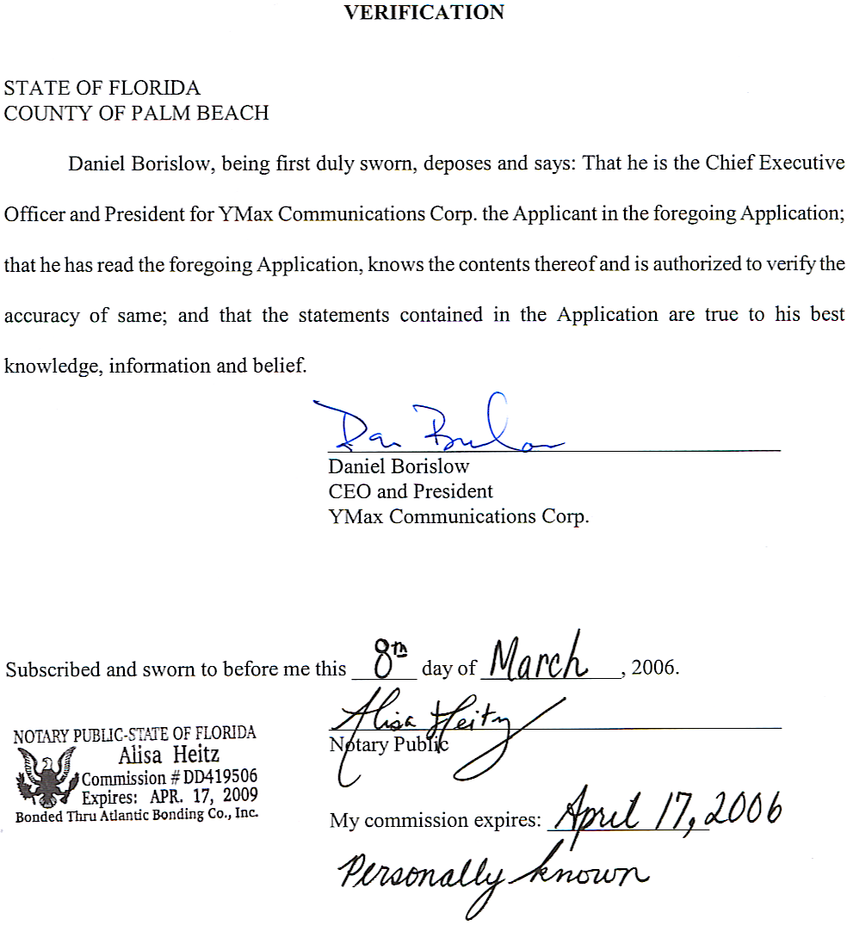

YMAX COMMUNICATIONS CORP.
APPENDIX A

Certificate of Authority
from
Missouri Secretary of State

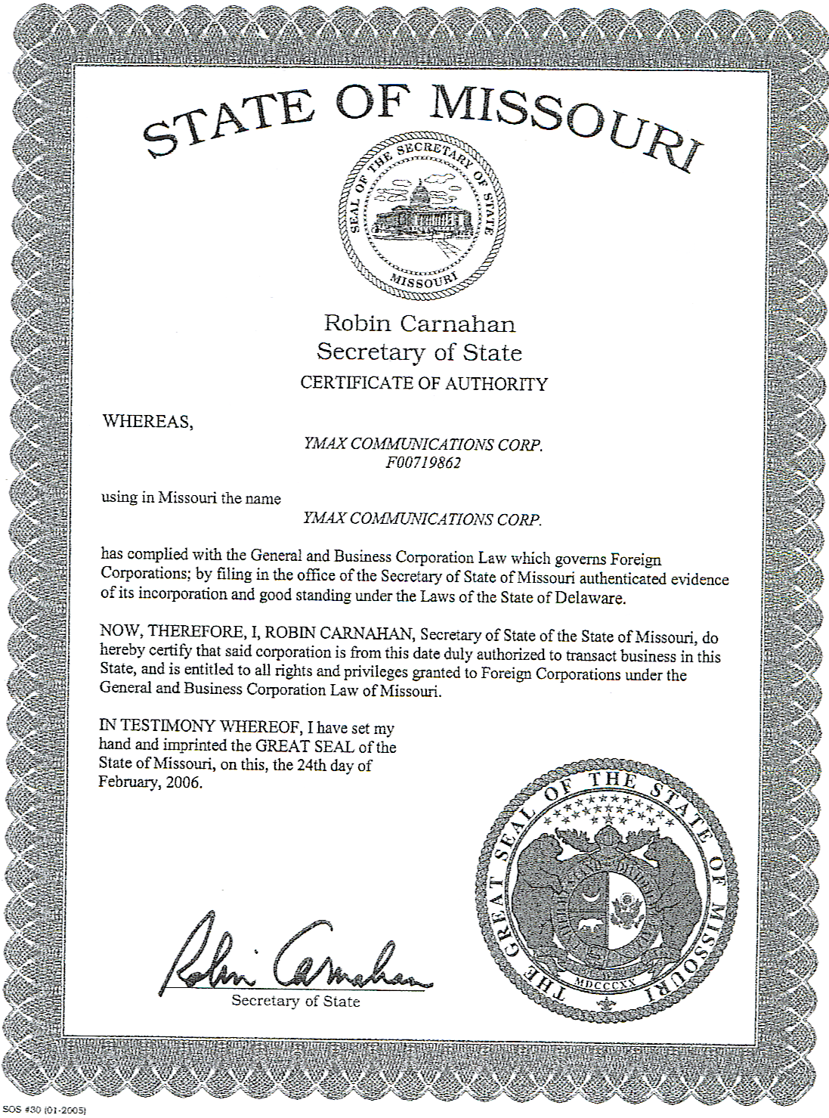YMAX COMMUNICATIONS CORP.

APPENDIX B

Profiles of Key Management Employees

YMax Communications Corp.
Management Profiles

Daniel Borislow

CEO, President, Chairman and Director

Daniel Borislow currently serves as the Chairman, Chief Executive Officer, President and Director of YMax Communications Corp. and resides in Palm Beach, Florida. He is a graduate of Widener University and was awarded an honorary Doctorate of Information Technology.

From May 1989 through January 1999, Mr. Borislow served as CEO and a Director of Tel-Save Holdings now Talk America. Tel-Save was a very profitable corporation. As the largest reseller and customer of AT&T, Tel-Save offered wholesale long distance to other resellers through marketing and partnership agreements. Mr. Borislow took his company public in 1995 and built his own long distance network by strategically deploying five (5) Lucent class 5E switches across the United States.

In 1997 Mr. Borislow negotiated exclusive marketing rights with America Online and Tel-Save and was the first company to offer services online with online billing, provisioning and customer service and a price point substantially lower than the rest of the market. Prior to founding Tel-Save, Mr. Borislow built the cable systems in the city of Philadelphia.

Mr. Borislow is an avid fisherman, horseman and philanthropist for education, cancer research and children’s athletics.

YMax Communications Corp.
Management Profiles, Continued

Gregory Lynn Wood

Chief Information Officer

Mr. Wood is currently employed by YMax Communications Corp. as a full-time outside consultant.

In 2005 Mr. Wood joined several of his former co-workers from Talk America, Inc. (f/k/a Tel-Save) in the formation of YMax Communications Corp. Prior to joining YMax, Mr. Wood was approached by Covista Communications to act as CIO, where he developed a complete rating, billing and customer service system that replaced Covista's legacy system.

Mr. Wood entered the telecommunications industry in 1991 when he was approached by American Telephone Company (ATN) to develop a rating and billing system. Mr. Wood joined the company full-time increasing the scope to include a full customer service system in addition to the rating and billing aspects.

In 1994, Talk America, who at that time was AT&T's largest reseller, decided to implement a nationwide network. Mr. Wood was approached to develop an entire rating, billing, and customer service system for this new platform.

In 1997, Talk America entered into an exclusive contract with America Online (AOL) to sell long distance to AOL's 10-million member base. Mr. Wood, having advanced to CIO, was called upon again to develop the first fully integrated online bill. Mr. Wood managed all aspects of this development project, taking the lead with the AOL developers.

From 1982-1992 Mr. Wood managed a chain of Value Added Retail Stores (VAR). After opening his own store he began custom software development that later led to a very vast Industrial Automation clientele. Notable clientele include Proctor and Gamble, Kimberly Clark, Quaker Oats, Asea Brown Bover (ABB), Kilgore, and Martin Marietta.

YMax Communications Corp.
Management Profiles, Continued

Peter J. Russo
Chief Financial Officer

Mr. Russo currently services as the Chief Financial Officer of YMax Communications Corp. and brings to that position extensive financial and management experience with both private and public companies.

From 2000-2005, Mr. Russo was the head of finance and operations for the thoroughbred horse racing and breeding business where he established bookkeeping and accounting systems, cash flow management and horse-by-horse analysis and billing. Mr. Russo prepared tax returns and directed IRS examination responses. He was responsible for dealing with sale companies, tracks, farms, trainers and licensing authorities and worked with various software packages as well as Brisnet, Equineline and Equibase.

From 1996-2000, Mr. Russo was Chief Financial Officer and Director of Operations for Group Long Distance, Inc. where he was responsible for financial operations, cash management, customer service and collections. He managed the IPO process and was responsible for credit agreements, carrier contracts and LEC billing arrangements. He implemented systems for financial reporting and cash flow monitoring and worked with Securities and Exchange Commission regulators, NASDAQ and various state Public Service Commissions. He was the head of Investor Relations requiring continual contact with the company's Board of Directors, investment bankers, shareholders and outside accountants. In this position, Mr. Russo performed due diligence and valuations for numerous acquisitions.

From 1996-1998, Mr. Russo was Senior Vice President, Corporate, Credit Administration and Operations for the State Bank of South Australia where he was responsible for a portfolio of assets that included senior and subordinated loans, syndications, asset-based lending and mezzanine financings. He managed all operational areas (loan and credit administration, accounting and finance, treasury support and funds transfer), and developed commercial loan modules, interest rate risk management systems and numerous operating policies and procedures, as well as established credit controls, loan grading systems and credit analysis functions. In addition, Mr. Russo headed the Corporate Loan Workout Section in order to maximize return on assets and minimize credit risk. Mr. Russo was a member of U.S. Lending Credit Committee and Treasury Risk Management Committee in the London office where, during a twelve month period, he put into place operating procedures and corporate lending guidelines that mirrored success in U.S. offices.

Additional experiences include First Vice President, Administrative Service Group for Australia and New Zealand Banking Group (1979-1988) and Staff Auditor for the Algemene Bank Nederland (1974-1978).

Mr. Russo holds a B.B.A. in Accounting (1978) from Pace University in New York, and is a graduate of American Bankers Association School of Bank Lending (1988) at the University of Oklahoma.

YMAX COMMUNICATIONS CORP.

APPENDIX C

Financial Information
(To be Late-Filed)

