Exhibit No.:
Issue: Class Cost-of-Service, Rate Design
Witness: Daniel I. Beck
Sponsoring Party: MoPSC Staff
Type of Exhibit: Direct Testimony
Case No.: GR-2002-356
Date Testimony Prepared: June 26, 2002

MISSOURI PUBLIC SERVICE COMMISSION

UTILITY OPERATIONS DIVISION

DIRECT TESTIMONY

OF

DANIEL I. BECK

LACLEDE GAS COMPANY

CASE NO. GR-2002-356

Jefferson City, Missouri

June 2002

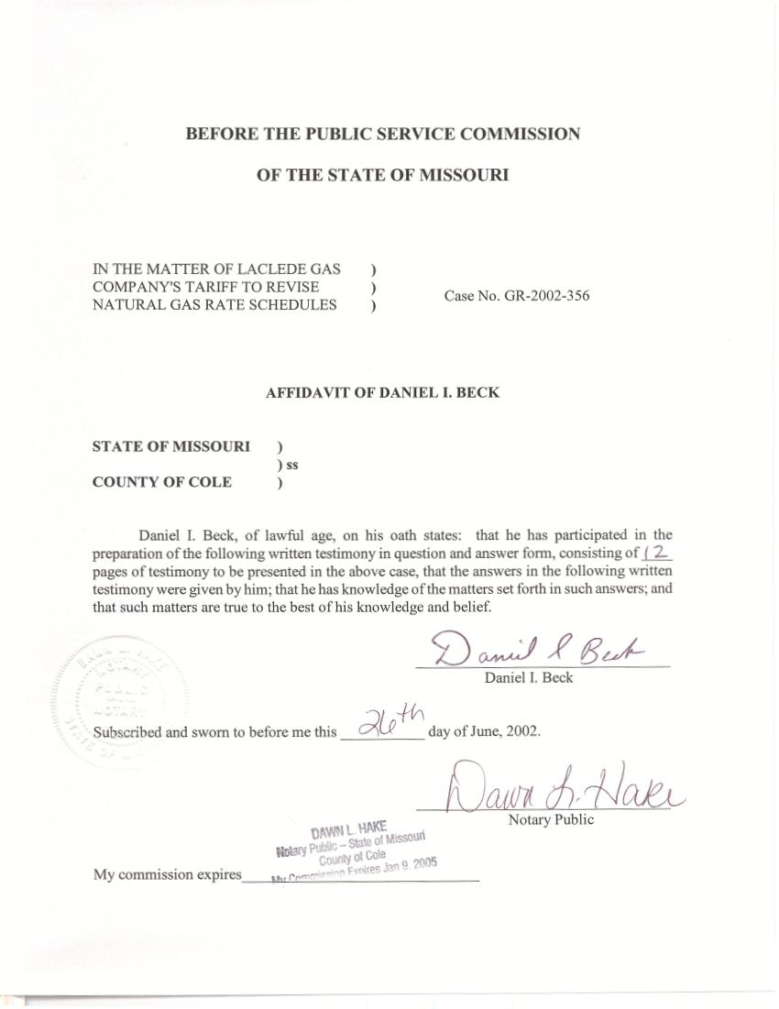
DIRECT TESTIMONY
OF
DANIEL I. BECK

LACLEDE GAS COMPANY
CASE NO. GR-2002-356

Q. Please state your name and business address.
A. My name is Daniel I. Beck and my business address is P. O. Box 360, Jefferson City, Missouri 65102.
Q. Are you the same Daniel I. Beck who submitted direct testimony regarding large customer normalization in the instant case, GR-2002-356?
A. Yes, I am.
Q. What is the purpose of your Direct Testimony?
A. The purpose of my Direct Testimony is to sponsor Class Cost-of-Service (CCOS) allocators that I developed and to discuss the various rate design alternatives that could be used in this case.
Q. What CCOS allocators did you develop?
A. I developed the allocators for mains, meters, regulators, and services.
Q. How did you develop these allocators?
A. I updated the allocators that were used in Laclede’s previous rate case to reflect current customer numbers and current estimates of weather normalized peaks.
Q. How would you define the term rate design?
A. Although many textbooks have been written on the subject of rate design, rate design is the process of developing the charges (or fees) necessary to collect the Commission-ordered revenue for a utility. To do this, there are several key issues that must be addressed. First, the rate design must consider the total dollars to be collected from each CCOS class. A CCOS class is a group of customers that have similar characteristics. Historically, the Staff has used the following CCOS classes for Laclede Gas Company (Laclede or Company): Residential (RES), General Service (GS), Interruptible (IN), Large Volume (LV), Large Volume Transportation Sales and Service – Basic (LVTSS-Basic or Basic), Large Volume Transportation Sales and Service – Firm (LVTSS-Firm or Firm), Propane, and Gas Lights. Once each class’ revenue responsibility is determined, the revenues are then collected using several basic charges:
- Customer charge – This is a monthly fee charged to each customer in a class. It normally increases as the size of the customers in a class increase. For example, for Laclede, the current RES customer charge is $12.00 per month while the LVTSS customer charge is $900.00 per month.
- Commodity Charge – This is a fee that is charged based on the gas that is used. This rate can be the same for each unit (for Laclede, units are measured in therms) or there can be blocked commodity rates; that is, rates that change as more gas is used.
- Demand Charge – This is a fee that is based on some measure of peak usage. For gas, it is normally peak day usage. Peak usage can be measured with special meters or estimated (although estimating methodologies are usually very simplistic and sometimes inexact).
Q. Have any significant changes been proposed in the rate design by the Company?
A. Yes. The Company has proposed a weather mitigation clause (WMC). This clause would adjust a customer’s bill during the winter to reflect the estimated dollars of under-recovery or over-recovery due to weather.
Q. Is the proposed charge resulting from the WMC a commodity charge as you previously defined it?
A. No. Although the final charge is collected on a volumetric basis, I maintain that this charge is not a traditional commodity charge since the charge varies with the deviation from normal weather. I would instead describe the WMC charge as a hybrid commodity charge that is attempting to recover under- or over-collected revenue due to non-normal weather and therefore “non-normal” usage.
Q. For which classes has the Company proposed to collect this revenue clause?
A. This proposed charge would only be collected from the RES and GS classes. Since the Company has limited the WMC to these two classes, which account for approximately 94% of the rate revenue (excluding the gas costs collected through the ACA/PGA Clause), I will limit my general rate design discussions to these two classes.
Q. Would a customer’s bill during the total winter season be the same from year to year if the WMC was adopted?
A. No. First, the ACA/PGA portion of a customer’s bill, which is typically more than half of their bill, is not affected by this WMC. This PGA portion of a customer’s bill has been the primary cause for the fluctuations in a customer’s winter bill over the past several winter seasons. Second, the WMC adjusts a customer’s bill based on that customer’ s current actual usage. If a customer’s total winter usage is abnormal for reasons other than weather, the total winter bill will be different from year to year.
Q. Is there a way to ensure that a customer contributes the exact same amount of non-PGA revenues each winter season?
A. Yes. The simplest way to ensure that a customer contributes the same amount each winter is to collect all of the rate revenues in the customer charge. If rate revenues were collected in this fashion, non-normal usage due to weather (or for any other reason) would have no effect on rate revenues collected by the Company.
Q. What level of customer charge would have to be implemented to collect current rate revenues from the RES and GS Classes?
A. For the RES Class a customer charge of $32.95 would have to be implemented to collect the same amount of winter revenue that is currently collected through both the customer charge and a charge added to the commodity. If a single customer charge was implemented year-round, a monthly RES customer charge of $24.30 would collect the annual revenue. For the GS Class, which currently has a customer charge of $15.00, a similarly calculated winter customer charge would be $125.68 per month and a year-round GS customer charge would be $79.50 per month.
Q. If the customer charges for the RES and GS Classes are currently within $3.00 of each other ($12.00 vs. $15.00), why would the simple customer charge rate design create a monthly difference of over $50.00 a month?
A. The average gas or commodity usage of the GS Class is significantly greater than that of the RES Class so that Laclede collects more of its costs from the commodity usage by this class. To state it another way, the large difference in calculated customer charges is needed to collect the additional revenue that is currently collected from the GS class by the commodity charge.
Q. How was the current combination of customer and commodity charges determined?
A. It was the result of discussions, negotiations and agreements among the parties in a series of Commission approved rate case settlements.
Q. Has Staff historically supported a method for calculating the level of the customer charge for gas utilities?
A. Yes. In my nearly 15 years with the Staff of the Commission, Staff has included the direct costs for meters, regulators, services meter reading and billing. In addition, the customer portion of mains has also been included in some calculations.
Q. Are there additional costs that could be included in the customer charge?
A. Yes. There is no specific list of items that must be included (or excluded) in the customer charge. In addition to the items listed in the previous section, one could also include the overhead costs that are associated with direct cost items could be included. By overheads, I am referring to any costs that are allocated to the classes based on the allocation of these specific items. For example, some administrative costs are allocated based on the allocation of total plant costs. Since meters, for example, are part of the items that make up the plant allocator, one could argue that the portion of administrative costs that is proportional to meters could be allocated based on these items. Although the resulting customer charge differs widely from utility to utility and study to study, in general, the inclusion of these associated costs would result in a customer charge of approximately $15.00 per month for the RES Class.
In addition, costs associated with demand can be collected in the customer charge. As I have previously discussed, customer charges are typically higher for the larger classes. These higher customer charges are partially related to the fact that larger customers have higher demands and therefore require larger facilities (meters, regulators, etc.). So, although the most obvious way to collect demand related costs would be through a demand charge, it is not the only way. The lack of good demand data and the definition of the customer classes makes the collection of demand related costs in the customer charge another possibility. As previously discussed the resulting customer charge differs widely from utility to utility and study to study, however, in general, the inclusion of these associated costs would result in a customer charge of approximately $19.00 per month for the RES Class.
Q. If the total customer charge to collect all non-gas costs is $24.30 per month and the inclusion of all costs including the demand costs accounts for approximately $19.00 per month, which costs account for the remaining $5.30 per month?
A. The remaining costs are generally defined as commodity related costs. As I have already discussed, the amount of commodity delivered to the customer (measured in therms for Laclede’s system) can and does vary from hour to hour, day to day, week to week, month to month and year to year. The most obvious cost that is directly related to this variation in usage is the cost of gas, however, this is collected through the ACA/PGA process. Other costs that are similarly related to commodity throughput are collected in the commodity charge.
Q. Since the amount of commodity usage is influenced by many factors, which include, but are not limited to weather and price, would the inclusion of these commodity related costs in the customer charge totally eliminate the variability of non-gas revenue collection?
A. Not entirely. The revenue collected by any rate or a combination of rates is subject to some variability in the basic billing units and, therefore, in the resulting revenues. However, the revenue from customer charges is much less sensitive to weather than is a commodity charge.
Q. Since a rate with a simple customer charge would meet one of the goals of the WMC by producing nearly constant non-gas revenues, should the Commission adopt a simple customer charge for all classes?
A. No, not without considering other goals and objectives. Although the goal of producing nearly constant non-gas revenues is one of the Company’s goals, other considerations need to be taken into account. Rate impacts are commonly considered with any rate design proposal.
Q. Please explain the term “rate impacts.”
A. Rate impacts are simply a calculation to determine the impact of a change in rates or in the rate design. While rate impacts may be easy to define, it is often difficult to gather the data necessary to determine the impacts.
Q. Why is all the data that is used to determine the rate design insufficient to calculate rate impacts?
A. Billing determinants used in rate design provide information on the classes in total and on average, however, this does not provide information about the impacts on high usage vs. low usage customers, low income vs. high income customers, space heating vs. non-space heating customers, etc. The impact on these groups of customers that exist within a given customer class cannot be determined by simply looking at total class data.
Q. If this data is not available at this time, how can the Commission ever make any change to rate design?
A. First, although this type of data is not available, it can be gathered by the Company prior to the next rate case. Second, the value of this data is proportional to the magnitude of the change in the rate design. For example, if the current RES rate design was modified by making a relatively small change in the customer charge, the impact on any given customer would also be rather small. However, the impact of a change in rate design, such as the elimination of the commodity charge discussed earlier, would likely have significant impacts (both positive and negative) on various customers and groups of customers.
Q. You referred to positive and negative impacts. Please explain.
A. Often, when we discuss the impacts of a proposed rate design, we dwell on the negative impacts. However, the impacts can be either positive or negative. In almost all cases, there are winners and losers with any change in a rate design.
Consider the following example to illustrate how rate impacts can be positive or negative where the Company’s total revenue and the revenue from a given class does not change. As is common, in this scenario, any change in rate design must shift revenues from one group of customers in a class to another. For simplicity, let’s assume that the Residential Class has two customers (customers A and B), the customer charge is $12.00, the commodity charge is 15 cents per therm, and the annual usage of customers A and B are 750 therms and 1000 therms, respectively. Currently, customer A contributes $256.50 and customer B contributes $294.00 for a total of $550.50 dollars in non-gas revenue each year. If the customer charge was increased 50 cents (the resulting commodity charge would be approximately 14.3 cents per therm), the new contributions for customers A and B would be $257.36 and $293.14, respectively, while still contributing the same total of $550.50. So in this case, the impact of the 50-cent increase in the customer charge would be less than a dollar a year and well below one percent (1%) change in their annual bill.
However, if the commodity charge were reduced to zero and all the revenue was collected in the customer charge, the new contributions would be $275.25 for each customer and the impact of the approximately $11.00 increase in the customer charge would be $18.75 per year for each customer with customer A “losing” and customer B “winning.”
Q. In your example, the two customers have significantly different annual usage, 750 therms vs. 1000 therms. Are customers’ usages in Laclede’s RES Class really this different?
A. Yes. In fact, these numbers approximate the average usage of two groups of Laclede’s RES customers, those in the Midwest Division and those in the Laclede Division. Since this example represents the average usage of two groups of customers, one can assume that when individual customers are considered, many customers’ usage will vary even more, both much higher and much lower.
Q. How can the data that is needed to determine the impacts be obtained?
A. Some of this data is in the Company’s billing records that were used to develop the billing units. However, the previous work with the billing units calculated totals for the classes and districts. To evaluate the impacts on various customers, the annual units for those customers will have to be calculated.
Other data, such as impacts on low-income customers is not available at this time. However, in Case No. GR-2001-292, Missouri Gas Energy (MGE) agreed to develop an experimental low-income program. A program like this would be a good opportunity to gather data on usage characteristics of low-income customers that could be used to evaluate impacts on their bill. In addition, there may be some information that is available regarding low-income customers from the weatherization program that the Company is currently conducting.
Q. Is there another way to offer some form of weather protection to residential customers?
A. Yes. While rate design proposals like the WMC and the reduction / elimination of the commodity charge provide some protection against weather related fluctuations in bills, the gas costs (or PGA/ACA costs), which account for the majority of a customer’s bill, can and do vary widely from year to year. In the Unanimous Stipulation and Agreement in GR-2001-629, Laclede agreed to explore the possibility of a fixed-bill service option. Such a mechanism would provide a portion of Laclede’s customers with the opportunity to have protection from fluctuations in their total bill, not just the non-gas portion of their bill noted earlier. This would also provide protection against price spikes in the cost of natural gas. The Company (or their representative) would be providing a form of insurance that would guarantee a fixed bill for the whole year.
Q. If the Company is providing insurance to the customer, would an “insurance” premium be charged?
A. Yes, most likely in some or several forms. Although the details of any fixed-bill service option have not been finalized, I would assume that the Company would receive some compensation for their exposure to the weather and price risks.
Q. Wouldn’t the lack of data to calculate customer impacts be a problem for the fixed-bill service option also?
A. No. Although the fixed-bill service option would be a significant change in rate design, part of the design is that it would be optional. Since each customer would have a chance to weigh the impact of the fixed-bill service option for themselves, the Commission would not need the same level of impact information for an optional plan.
Q. Are there any additional costs that are recovered with a commodity rate that could be collected in a customer charge?
A. Other than the Company’s non-gas costs, there are some costs that are recovered through the ACA/PGA rate that could be included in the customer charge. The costs for Capacity Reservation and Gas Supply Demand are approximately one-third as large as the non-gas costs. Given the significant magnitude of this portion of the PGA costs, the collection of these costs through a customer charge would provide additional bill stability for customers and for Laclede.
Q. If the costs for Capacity Reservation and Gas Supply Demand are relatively fixed, could these costs be recovered in non-gas rates?
A. Although these costs have previously been defined as gas costs, their inclusion in non-gas rates, especially in a customer charge, would be logical since the PGA costs have always been recovered through a commodity rate, which has always been viewed as a variable charge.
Q. Could a PGA rate include both a commodity and a customer charge?
A. Although there has never been a customer charge portion of the PGA, the design of the PGA rate, like the design of the non-gas rate, is ultimately a policy decision that the Commission can make.
Q. Earlier, you presented estimated customer charge values for the GS Class that assumed that the commodity charge portion of the non-gas cost was zero. This resulted in a customer charge of $125.68 for the winter or $79.50 year-round. Could you support either of these customer charge levels?
A. Although I do not have all of the impact data necessary to fully evaluate this proposal, I would be very hesitant to implement such a proposal. My experience tells me that this customer class is extremely diverse. Many utilities have this group of customers divided into two groups of customers: the Small General Service (SGS) Class and the Large General Service (LGS) Class. If this group were divided into two classes, the LGS customer charge could easily be set well above the $15.00 level and still allow for some costs to be collected in the commodity charge. If the stabilization of the non-gas revenues is a concern, the division of the GS Class should be considered.
Q. Does this conclude your Direct Testimony?
A. Yes, it does.

