Exhibit No.:
Issues: Transportation Service-Internal
Deferred Carrying Cost Balance
Witness: Annell G. Bailey
Sponsoring Party: MoPSC Staff
Type of Exhibit: Surrebuttal Testimony
Case No.: GR-2001-388
Date Testimony Prepared: February 20, 2003

MISSOURI PUBLIC SERVICE COMMISSION

UTILITY SERVICES DIVISION

SURREBUTTAL TESTIMONY

OF

ANNELL G. BAILEY

SOUTHERN MISSOURI GAS COMPANY, L.P.

CASE NO. GR-2001-388

Jefferson City, Missouri

February 2003
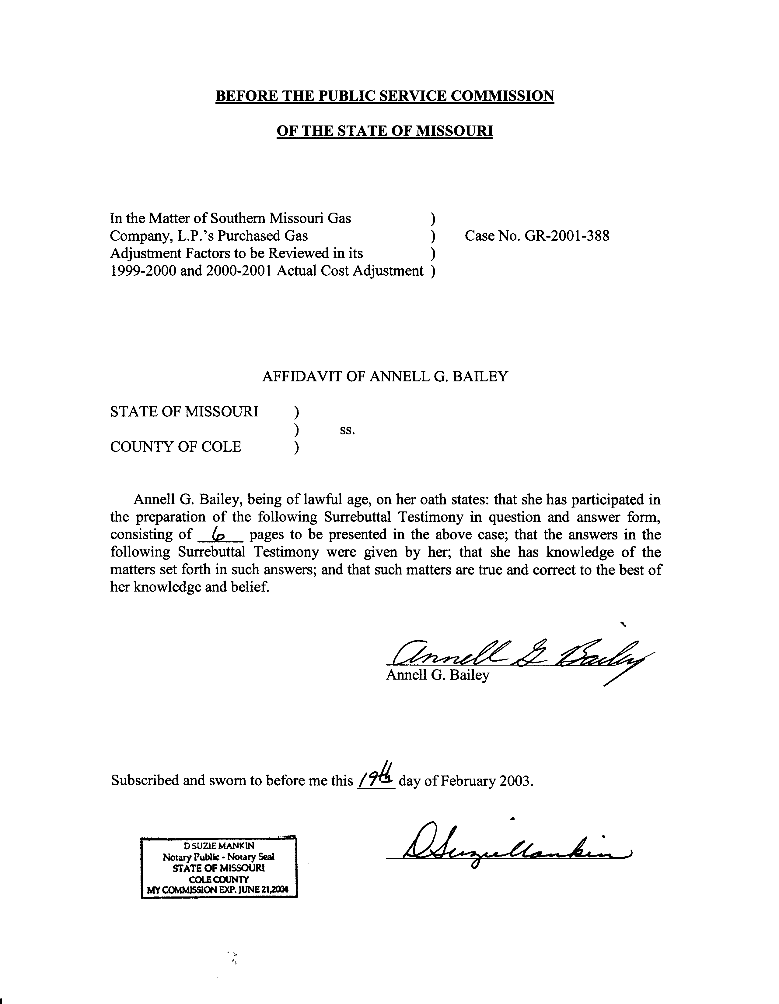
TABLE OF CONTENTS OF
SURREBUTTAL TESTIMONY OF
ANNELL G. BAILEY
SOUTHERN MISSOURI GAS COMPANY, L.P.
CASE NO. GR-2001-388
TRANSPORTATION SERVICE -- INTERNAL 1
DEFERRED CARRYING COST BALANCE 5

SURREBUTTAL TESTIMONY
OF
ANNELL G. BAILEY
SOUTHERN MISSOURI GAS COMPANY, L.P.
CASE NO. GR-2001-388
Q. Please state your name and business address.
A. Annell G. Bailey, P.O. Box 360, Jefferson City, Missouri 65102.
Q. Are you the same Annell G. Bailey who filed direct testimony and rebuttal testimony in this case?
A. Yes.
Q. What is the purpose of your surrebuttal testimony?
A. The purpose of my surrebuttal testimony is to rebut portions of the rebuttal testimony (filed January 30, 2003) and the supplemental direct testimony (filed February 12, 2003) of Southern Missouri Gas Company, L.P. (SMGC or Company) witness Scott F. Klemm in two areas: 1) Transportation Service – Internal; and 2) Deferred Carrying Cost Balance (DCCB).

TRANSPORTATION SERVICE -- INTERNAL
Q. Mr. Klemm states on page 2 of his Rebuttal Testimony: “Staff’s position is based upon the unrealistic assumption that, absent the measures taken by the Company to retain two industrial customers on the system, there would have been an increase of revenues of $105,809, ‘if the gas had been sold at the authorized PGA-adjusted rate.’” Was that the basis of your position?
A. No. I made no assumptions about what might have happened. My position was based entirely on the belief that the Company had sold natural gas in violation of its tariff.
Q. How did you arrive at the amount of $105,809?
A. Given that the tariff had been violated, my aim was to restore the Actual Cost Adjustment (ACA) balance and the Company’s other customers to where they would have been if no tariff violation had occurred, other facts remaining the same. It is a fact that the Company sold a verifiable quantity of gas to the two “Transportation Service – Internal” customers. It is a fact that the Company had a tariff authorizing a Purchased Gas Adjustment (PGA) rate for sales of gas. The only realistic option was to compute the PGA revenue that would have been received if the known sales volume had been sold at the authorized PGA rate. That computation totaling $105,809 was attached to my Direct Testimony as Schedule 1. Since then, Staff has agreed with two of the Company’s requested changes (explained later in this surrebuttal testimony), resulting in a revised Staff adjustment of $102,137 to the ACA balance and a $2,938 adjustment to the Refunds balance. (See attached Surrebuttal Schedule 1)
Q. Did you make alternative computations to show the impact if these two industrial customers had left the SMGC system or reduced their throughput?
A. As I stated in my Rebuttal Testimony, any such computations would have been based on guesswork and conjecture about an infinite number of imagined actions and reactions of the part of the Company and the two customers. There was no realistic way to support such computations.
Q. Mr. Klemm states on page 3 of his Rebuttal Testimony that Staff does not identify in direct testimony the basis for its conclusion that “Transportation Service – Internal” is an “unauthorized service” and a “violation of Commission rules and SMGC’s tariff on file with the Commission.” Has the basis for that conclusion been identified?
A. Yes. Please refer to the rebuttal and surrebuttal testimony of Staff witness James M. Russo for an explanation of the tariff authorization issue.
Q. Do you agree with the following statements made by Mr. Klemm?
[T]he profit [from gas sales to “Transportation Service – Internal” customers] was used to reduce the amount that other ratepayers would have to pay for the uncollected ACA balance. In other words, SMGC’s remaining customers directly benefited from the fact that SMGC was able to negotiate a contract that recovered its variable costs and made a contribution to the fixed costs of the system. SMGC did not retain any of the revenues from the gas supply contract as a fee for providing this service.

. . . .

. . . If these customers had left the system, the remaining ratepayers would have had to absorb the entire remaining uncollected ACA balance from previous periods. (Rebuttal, p. 10, l. 13 through p. 11, l. 5)
A. Yes. Based on my audit work, the profit from gas sales to the two “Transportation Service – Internal” customers was used to reduce the ACA balance by $39,987 (See attached Surrebuttal Schedule 1). This contribution would not have been made if the customers had left the system and that gas had not been sold. However, as I explained in my Rebuttal Testimony, Surrebuttal Schedule 1 also shows that if the gas had been sold to those two customers at tariff-authorized rates, the contribution would have been $102,137 more than the actual $39,987. Whether the customers would have left the system or whether they would have paid the PGA rates is a matter of conjecture. Finally, the Company’s motive and use of the profits is irrelevant to the key question of whether the Company has violated its tariff.
Q. Can you comment on this statement from page 15 of Mr. Klemm’s Rebuttal Testimony?
A $105,809 adjustment is a very substantial adjustment for a small company of SMGC’s size. In fact, SMGC’s Net Utility Operating Income for the year ended December 31, 2001, was $155,703. The Staff’s proposed disallowance would represent nearly 68% of SMGC’s Net utility Operating Income for 2001. This is a very substantial penalty….
A. Yes. The $105,809 is not a penalty. As I stated above, the adjustment is intended to restore the ACA balance and the Company’s other customers to where they would have been if no tariff violation had occurred, other facts remaining the same. This ACA case is not the appropriate case for consideration of penalties.
Q. Do you agree with Mr. Klemm’s statement (Rebuttal Testimony, page 16) that Staff’s proposed disallowance does not consider the Refunds (i.e. negative numbers) that are part of the PGA rate?
A. Yes. I excluded Refunds because there is separate accounting for Refunds under the tariff. (See attached Surrebuttal Schedule 1) Although refunds are an adjustment to the rates that are charged to customers, the tariff does not allow them to be included in the ACA balance that is carried forward for recovery in future years. Adjustments to the ACA balance are the subject of this case. According to the Company’s tariff, Sheet 26:
The Company shall establish and maintain a Deferred Purchased Gas Cost – Actual Cost Adjustment (ACA) Account which shall be credited with any over-recovery resulting from the operation of the Company’s PGA procedure or debited for any under-recovery resulting from the same.
Such over- or under-recovery shall be determined by a monthly comparison of the actual (as billed) cost of gas as shown on the books and records of the Company for each cost month, exclusive of refunds, [emphasis added], TOP costs and penalties, to the cost recovery by the Company for the revenue month corresponding to the cost month.
However, as shown in the attached Surrebuttal Schedule 1, the Refunds account should be separately adjusted by $2,938.
Q. Do you agree with Mr. Klemm’s statement (Rebuttal, page 16) that Staff computed the revenues using the million British thermal units (MMBtu) volumes and not the hundred cubic feet (Ccf) volumes?
A. Yes. This is true because Staff was being consistent with the Company:
1) The Company’s invoices to its “Transportation Service – Internal” customers are expressed in MMBtu. These customers are the reason for the disallowance.
2) In the Company’s support for its ACA filing of November 8, 2001 (the subject of this case) the Company computed all of its revenues in thousands of cubic feet (MCF). It is a standard practice to covert on the basis that one MCF = one MMBtu.
However, Staff has now accepted Mr. Klemm’s conversion rates. The reason is that the Staff has seen documentation in the form of Statements of Deliveries from Williams Natural Gas, showing actual MCF volumes and the related MMBtu’s. With this evidence to support a conversion rate that is outside the norm, the Staff is willing to adjust the disallowed amount down from $105,809 to $102,137. (See attached Surrebuttal Schedule 1)

DEFERRED CARRYING COST BALANCE
Q. Do you agree with the following statement, “Based upon these discussions [with other LDC’s], it is my understanding that the LDC industry in Missouri has historically based the interest calculation for the DCCB on the PGA rate only, not including the ACA factor….” from page 2 of Mr. Klemm’s Supplemental Direct Testimony?
A. Yes and no. Staff’s position is that other LDC’s have their own tariffs, separate and in some ways different from SMGC’s tariff. Therefore, other LDCs’ practices are irrelevant. However, Staff has accepted Mr. Klemm’s adjustment and has recalculated Staff’s DCCB calculation to include only the PGA rate and exclude the ACA rate. (See attached Surrebuttal Schedule 2) Staff’s change is based on SMGC’s tariff, Sheet 26: “The cost recovery shall be calculated by multiplying the PGA class Ccf sales by the applicable [emphasis added] effective revenue components (the RPGA factor and the ACA factor) related to the cost of gas purchased.”
Staff noted that the DCCB calculation includes only the current year’s sales (related to the PGA factor) and excludes the prior period ACA balance (related to the ACA factor). Therefore, only the PGA factor is applicable and has been used on the revised Surrebuttal Schedule 2.
Q. Have you made any other adjustments to the DCCB Schedule?
A. Yes. In our original DCCB calculation (Schedule 1 attached to my Direct Testimony), column (F) “Billed Sales Volumes (Ccf)” excluded the volumes of gas sold to Transportation Service – Internal customers. We noted that this is inconsistent with our position that those sales should be treated as regular PGA sales. Therefore, we added them to the revised DCCB calculation, attached as Surrebuttal Schedule 1. The resulting interest due to the Company is $11,595, an increase from our original calculation $2,024.
Q. Does this conclude your Surrebuttal Testimony?
A. Yes.

