Exhibit No.:
Issue: Large Customer Adjustments
Witness: Daniel I. Beck
Sponsoring Party: MoPSC Staff
Type of Exhibit: Direct Testimony
Case No.: GR-2002-356
Date Testimony Prepared: June 20, 2002

MISSOURI PUBLIC SERVICE COMMISSION

UTILITY OPERATIONS DIVISION

DIRECT TESTIMONY

OF

DANIEL I. BECK

LACLEDE GAS COMPANY

CASE NO. GR-2002-356

Jefferson City, Missouri

June 2002

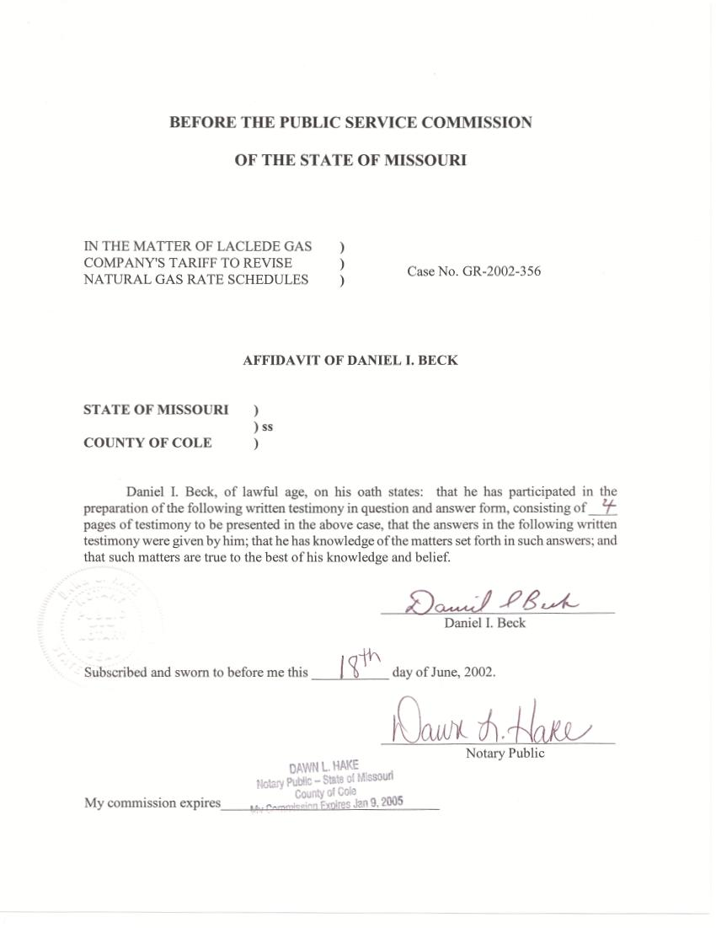
DIRECT TESTIMONY
OF
DANIEL I. BECK

LACLEDE GAS COMPANY
CASE NO. GR-2002-356

Q. Please state your name and business address.
A. My name is Daniel I. Beck and my business address is P. O. Box 360, Jefferson City, Missouri 65102.
Q. By whom are you employed and in what capacity?
A. I am employed by the Missouri Public Service Commission (MOPSC or Commission) as a Utility Regulatory Engineer in the Utility Operations Division.
Q. Would you please review your educational background and work experience?
A. I graduated with a Bachelor of Science Degree in Industrial Engineering from the University of Missouri at Columbia in 1983. Upon graduation, I was employed by the Navy Plant Representative Office in St. Louis, Missouri, as an Industrial Engineer. I began my employment at the Commission in November 1987 in the Research and Planning Department of the Utility Division (later renamed the Economic Analysis Department of the Policy and Planning Division) where my duties consisted of weather normalization, load forecasting, integrated resource planning, cost-of-service and rate design. In December 1997, I was transferred to the Rate Design/Tariff Section of the Commission’s Gas Department where my duties included weather normalization, annualization, tariff review, cost-of-service and rate design. Since June 2001, I have continued with the same duties in
the Engineering Analysis Section of the Energy Department, which was created by combining the Gas and Electric Departments. I am a Registered Professional Engineer in the State of Missouri. My registration number is EN 026953.
Q. Have you previously testified before this Commission?
A. Yes, I have. Schedule 1 is a list of cases in which I have testified.
Q. What is the purpose of your direct testimony?
A. The purpose of my direct testimony is to sponsor adjustments to the large customers revenues related to weather normalization, the effect of interruptions, and typical usage. The large customers can more specifically be described as: the Large Volume Service (LV), Interruptible Service (IN), and Large Volume Transportation and Sales Service (LVTSS) Classes. I have provided these adjustments to Staff Witness John P. Cassidy.
Q. You stated that you made adjustments related to weather normalization, the effect of interruptions, and typical usage. What relationship, if any, do these adjustments have to one another?
A. Although I made separate adjustments for each of these three situations, the three are related, since most of these adjustments were calculated using regression analysis.
Q. Could you give an example of the regression analyses that you performed?
A. Yes. For the LVTSS class, since all customers are billed at the end of the month, the regression analysis compared monthly usage to actual heating degree days (HDD) for a calendar month. Once the relationship between usage and weather was determined, monthly adjustments to reflect normal weather were determined. An adjustment reflecting the weather adjustments for these classes is shown in Staff’s Accounting Schedules as Adjustments S-2.5 for the LV class, S-3.1 for the IN Class and S-4.2 for the LVTSS Class.
In addition to weather, the regression analysis showed that December 2000, January 2001, and February 2002 usage was lower than expected for the LVTSS Class. In my opinion, this low usage was the result of supply constraints and record gas prices. Since most of the Company-imposed interruptions occurred in December 2000, I have attributed the low usage in December to these interruptions. For the remaining non-typical usage adjustments in January and February 2001, I concluded that the primary reason for the non-typical low usage was the record high market prices for natural gas. Please note that the January and February non-typical usage was significant only for Basic Transportation, which is a subclass of the LVTSS Class. The interruption effect is shown in adjustment 3.5 for the IN Class and adjustment 4.5 for the LVTSS Class. The price effect is shown in adjustment 4.4 for the LVTSS Class.
Q. The remaining large customer classes are the IN and the LV Classes. Did you use the same regression analysis methodology on these classes?
A. Yes. However, these classes have customers whose meters are read on different read dates. I developed weighted monthly HDDs to account for the diversity in the reading dates. (The LV Class has at least one customer with a meter that is read on each of the twenty-one billing cycles while the IN Class has at least one customer with a meter that is read on eleven of the twenty-one billing cycles.) In addition, for the IN Class, the price effect adjustment was determined not to be significant and, therefore, was not included. For the LV Class, neither the interruption effect adjustment nor the price effect adjustment was determined to be significant.
Q. What was the source of the data used in your regression analysis?
A. Staff witness Anne Ross, of the Energy Department, supplied the usage data for the large customer classes. Staff witness Dennis Patterson, of the Energy Department provided the daily HDD values.
Q. Does this conclude your direct testimony in this part of the case?
A. Yes, it does. However, I will also be filing direct testimony on cost-of-service and rate design.
Laclede Gas Company
Case No. GR-2002-356

List of Cases in which prepared testimony was presented by:
DANIEL I. BECK

Company Name Case No.

Union Electric Company EO-87-175
The Empire District Electric Company EO-91-74
Missouri Public Service ER-93-37
St. Joseph Power & Light Company ER-93-41
The Empire District Electric Company ER-94-174
Union Electric Company EM-96-149
Laclede Gas Company GR-96-193
Missouri Gas Energy GR-96-285
Kansas City Power & Light Company ET-97-113
Associated Natural Gas Company GR-97-272
Union Electric Company GR-97-393
Missouri Gas Energy GR-98-140
Missouri Gas Energy GT-98-237
Ozark Natural Gas Company, Inc. GA-98-227
Laclede Gas Company GR-98-374
St. Joseph Power & Light Company GR-99-246
Laclede Gas Company GR-99-315
Utilicorp United Inc. & St. Joseph Light & Power Co. EM-2000-292
Union Electric Company d/b/a AmerenUE GR-2000-512
Missouri Gas Energy GR-2001-292
Laclede Gas Company GR-2001-629
Union Electric Company d/b/a AmerenUE GT-2002-70

