Exhibit No.:
Issues: Rate Design, Class Cost of Service
Witness: Daniel I. Beck
Sponsoring Party: MO PSC Staff
Type of Exhibit: Direct Testimony
Case No.: GR-2004-0209
Date Testimony Prepared: April 22, 2004

MISSOURI PUBLIC SERVICE COMMISSION

Utility Operations DIVISION

DIRECT TESTIMONY

OF

DANIEL I. BECK

MISSOURI GAS ENERGY

CASE NO. GR-2004-0209

Jefferson City, Missouri
April, 2004

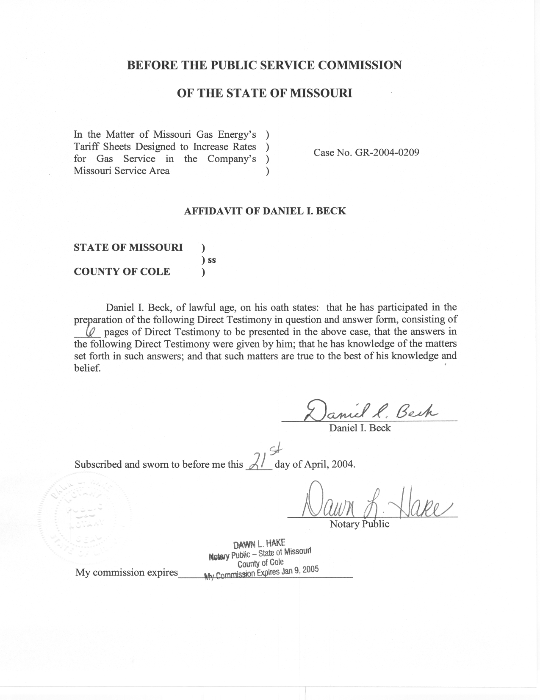
TABLE OF CONTENTS

CLASS COST OF SERVICE 2
RATE DESIGN 5

DIRECT TESTIMONY
OF
DANIEL I. BECK
MISSOURI GAS ENERGY
CASE NO. GR-2004-0209
Q. Please state your name and business address.
A. My name is Daniel I. Beck and my business address is Missouri Public Service Commission, P. O. Box 360, Jefferson City, Missouri 65102.
Q. What is your present position with the Missouri Public Service Commission (MOPSC or Commission)?
A. I am employed by the Commission as a Utility Regulatory Engineer in the Utility Operations Division.
Q. Would you please review your educational background and work experience?
A. I graduated with a Bachelor of Science Degree in Industrial Engineering from the University of Missouri at Columbia. Upon graduation, I was employed by the Navy Plant Representative Office in St. Louis, Missouri as an Industrial Engineer. I began my employment at the Commission in November, 1987, in the Research and Planning Department of the Utility Division (later renamed the Economic Analysis Department of the Policy and Planning Division) where my duties consisted of weather normalization, load forecasting, integrated resource planning, cost-of-service and rate design. In December, 1997, I was transferred to the Tariffs/Rate Design Section of the Commission’s Gas Department where my duties include weather normalization, annualization, tariff review, cost-of-service and rate design. Since June 2001, I have continued with the same duties in the Engineering Analysis Section of the Energy Department, which was created by combining the Gas and Electric Departments. I am a Registered Professional Engineer in the State of Missouri. My registration number is E-26953.
Q. What is the purpose of your direct testimony?
A. The purpose of my direct testimony is to introduce the Class Cost of Service study that I developed and to discuss the Staff’s proposed rate design for this case.

CLASS COST OF SERVICE
Q. Did you develop a Class Cost of Service study in Case No. GR-2004-0209?
A. Yes. I updated the Class Cost of Service (CCOS) study that I filed in Case GR-2001-292, which was Missouri Gas Energy’s (MGE’s) previous rate case.
Q. What is the purpose of a CCOS study?
A. MGE has several different classes of customers. A CCOS study indicates the revenue responsibilities of the various cost of service classes and the related customer charges. To state it another way, the CCOS determines how much of MGE’s revenue requirement should be assigned to each of the classes of customers.
Q. What classes are used in your CCOS study?
A. Staff’s CCOS study included four (4) classes. These classes are: Residential (RES), Small General Service (SGS), Large General Service (LGS), and Large Volume Service (LVS). The Unmetered Gas Light Class that was previously included in MGE’s CCOS studies was removed due to the extremely small size of this class’s revenue contribution and the related expenses.
Q. Please describe how Staff’s CCOS study in Case No. GR-2001-0292 was updated.
A. First, all costs were adjusted to reflect the values in the Staff Accounting Schedules, which were filed in this case on April 15, 2004. To make these adjustments to costs, several hundred values were entered into Staff’s CCOS study. To my knowledge, the only costs that did not change when compared to the previous study where several accounts with a balance of zero. Next, all customer numbers, sales and peak demands were modified to reflect the values provided by Staff in the current case. By updating customer numbers, sales, and peak demands, every allocator was modified either directly or indirectly.
Q. Are all of the cost components based on the current Accounting Schedules?
A. Yes. Staff’s Accounting Schedules include an estimated true-up allowance adjustment of $2,500,000 which was not included in Staff’s CCOS Study since this adjustment cannot be assigned to a single account or a group of accounts. Since any change in an account balance could affect the overall results of the CCOS study, I would propose to update the CCOS study to reflect these changes as they become known later in the rate case process. However, I should note that my past experience has been that most changes of this nature have very little affect on the CCOS results.
Q. Were there changes in customer numbers, sales and peak demands between Case No. GR-2001-0292 and Case No. GR-2004-0209?
A. Yes, but considering that there was two and one-half years between the test year in the two respective cases, the changes were relatively minor. However, these values all reflect the test year ending June 30, 2003, updated through December 31, 2003, that was ordered by the Commission in Case GR-2004-0209.
Q. Were there any values that should be noted?
A. In my opinion, the most notable values, the current margin revenues, actually changed very little (less than 10%) between Staff’s CCOS study filed in GR-2001-0292 and the one filed in the current case. However, when only values from the current case are compared, these same values differ by more than 20% when Staff’s current revenues are compared with the Company’s filed current revenues. Most notable are the differences between the current revenues for the SGS and LGS classes. Although several issues like the Company’s proposed Apartment/Rental Unit Reclassification can explain some of the differences, the parties to this case need to account for and resolve these differences if possible.
Q. Why is it important to account for differences in revenues?
A. Because such differences typically affect both current revenues and the associated billing units. Therefore, the effect of such differences is often compounded since revenues and billing units are components of calculating the final rate that a customer will be charged. Therefore, I maintain that the parties should make it a priority to account for and resolve any differences between revenues and billing units.
Q. You stated that there were several hundred values that changed when you updated your CCOS study. Are you planning to discuss each change in this testimony?
A. No, in my opinion, that would not be a productive use of either my time or the time of anyone reading this testimony. Instead, I have included my calculations in my work papers and I plan to address the significant differences between the various CCOS studies filed in this case in my Rebuttal Testimony. In my opinion, identifying the areas where there is significant disagreement and discussing these areas more thoroughly is a more productive use of everyone’s time.
Q. Earlier, you mentioned the term allocator. Could you define this term?
A. An allocator, in the context of a CCOS study, is the set of numbers used to assign the Company’s various cost components to each cost of service class. The analyst attempts to choose allocators that are related to each of the various accounts. The results of Staff’s CCOS study are shown on Schedule 1.

RATE DESIGN
Q. What do you propose regarding revenue shifts between classes?
A. After reviewing the results of Staff’s CCOS study, I conclude that most of the classes are at or near their class revenue responsibility. However, one class, the Large General Service Class, appears to be the only class that has a difference between revenues and required margin revenues that is greater than 10%. However, as I discussed earlier, the LGS Class is one of the classes were Staff and the Company show significantly different current revenues. Therefore, I cannot recommend that revenues be shifted between classes at this time. In addition, while the Company is proposing to increase current margin revenues by about 33%, Staff is proposing almost no change. Any change in class revenue responsibility should take into account the impact of the increase in the total and class revenue requirement.
Q. Do the issues of current revenues and the overall revenue requirement also need to be considered in designing rates?
A. Yes, these issues need to be considered when designing rates. Therefore, I do not propose to change the current rate design at this time. However, as more information about these issues is clarified, the rate design should be reconsidered.
Q. Are there any other issues that you maintain have rate design implications?
A. Yes. The Company proposed to reclassify apartment/rental unit customers in response to a proposal from the Office of The Public Counsel (OPC) in the previous rate case, Case No. GR-2001-0292. While I was supportive of OPC’s proposal, I cannot support the Company’s proposed implementation of this idea in this rate proceeding. OPC intended to ensure that single-family or individually metered multiple family dwellings be treated as Residential customers. However, the Company’s proposed implementation would allow customers with usage of five times the usage of an average residential customer to change classes. In addition, this proposal would literally shift millions of dollars between classes and eliminate over $400,000 worth of current revenue. Such changes would have significant effects on rates and rate design.
In addition, the Company proposed a “weather mitigation” rate design for the Residential and SGS classes while also raising the weather related issues of rate of return, weather normalization, and load attrition. The impact of all these issues must be considered before any weather mitigation rate design is implemented.
Finally, changes in current revenues resulting from tariff issues and miscellaneous service charges should be considered when determining revenue shifts between classes and rate design. Staff’s Accounting Schedules do not include the impact of several miscellaneous service charge changes that are being proposed.
Q. Does this conclude your direct testimony?
A. Yes, it does.

