Exhibit No.:
Issues: Class Cost of Service,
Rate Design

Witness: Daniel I. Beck
Sponsoring Party: MO PSC Staff
Type of Exhibit: Surrebuttal Testimony
Case No.: GR-2004-0209
Date Testimony Prepared: June 14, 2004

MISSOURI PUBLIC SERVICE COMMISSION

UTILITY OPERATIONS DIVISION

SURREBUTTAL TESTIMONY

OF

DANIEL I. BECK

MISSOURI GAS ENERGY

CASE NO. GR-2004-0209

Jefferson City, Missouri
June 2004
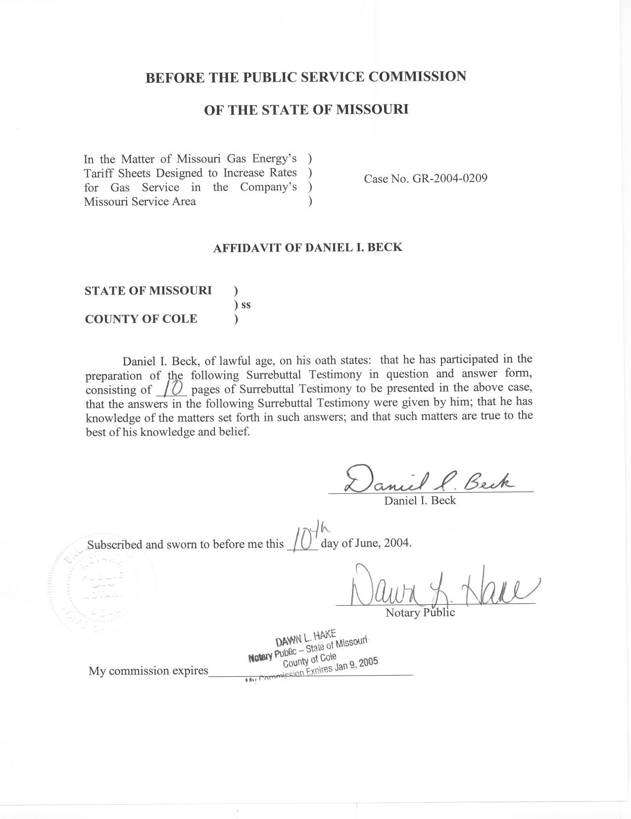
TABLE OF CONTENTS

LOAD ATTRITION ADJUSTMENT 1
CLASS COST OF SERVICE 3
RATE DESIGN 6

SURREBUTTAL TESTIMONY

OF

DANIEL I. BECK

MISSOURI GAS ENERGY

CASE NO. GR-2004-0209

Q. Please state your name and business address.
A. My name is Daniel I. Beck and my business address is Missouri Public Service Commission, P. O. Box 360, Jefferson City, Missouri 65102.
Q. Are you the same Daniel I. Beck that filed Direct and Rebuttal Testimony in this case?
A. Yes, I am.
Q. What is the purpose of your Surrebuttal testimony?
A. The purpose of my surrebuttal testimony is to discuss the Company’s proposed Load Attrition Adjustment, the Class Cost of Service Rebuttal filed by the other parties and the rate design Rebuttal filed by the other parties in this case.

LOAD ATTRITION ADJUSTMENT
Q. Did the other parties file any Rebuttal Testimony regarding the Company’s proposed Load Attrition Adjustment?
A. Yes. However, the only Rebuttal Testimony regarding the Load Attrition Adjustment was sponsored by Company witness F. Jay Cummings and consisted of three lines confirming that no other party filed Direct Testimony on the Load Attrition Adjustment.
Q. Do you have any corrections to your Rebuttal Testimony regarding the Load Attrition Adjustment?
A. Yes. On page 12, lines 5-6, I stated that no class/district combinations showed a significant summer trend factor. While reviewing my Rebuttal workpapers, I discovered that one class out of nine, the Large General Service (LGS) class for St. Joseph, showed a significant summer trend. This class/district accounted for only $9,270 of the $1,629,718 Load Attrition Adjustment.
On page 12, lines 6-8, I stated that, assuming Dr. Cummings definition of significance, two class/district combinations showed a significant summer trend factor. As stated above, the LGS class for St. Joseph shows significant summer trend, so by Dr. Cummings definition, three class/district combinations showed a significant summer trend. However, these three class/district combinations account for a small amount (approximately 16%) of the total load attrition adjustment and the other two class/districts’ summer trends are only marginally significant, even by Dr. Cummings’ definition.
Q. Since the summer trend was significant for the LGS class in the St. Joseph district, is there anything that should be noted about this summer trend variable?
A. Yes. The summer trend variable is 38% of the magnitude of the winter trend variable for the LGS class in St. Joseph. Therefore, even for the one exception, the summer trend estimate is much lower than the winter trend estimate. Clearly, Dr. Cummings’ Load Attrition Adjustment for the summer months is vastly overstated.
Q. Given this new information, do you continue to oppose the Load Attrition Adjustment?
A. Yes. For the same six reasons that I stated in my Rebuttal Testimony, I continue to oppose the Company’s Load Attrition Adjustment.

CLASS COST OF SERVICE
Q. Have you reviewed the Class Cost of Service Rebuttal Testimony filed in this case?
A. Yes. Most of the Rebuttal was directed at the three Class Cost of Service (CCOS) Studies filed in Direct Testimony. In addition, Federal Executive Agencies (FEA) witness Gary C. Price introduced a fourth CCOS study in his Rebuttal Testimony.
Q. What are your impressions of Mr. Price’s CCOS study?
A. With a few exceptions as noted by Mr. Price, the allocators used are based on the Company’s CCOS Study and the costs are based the Staff’s Direct filed revenue requirement. The results are nearly identical to the MGE CCOS study as corrected by Mr. Price. In my opinion, since most of the allocators are based on the Company’s study, the primary benefit of this study is that it confirms that percentages provide a reasonable method to compare studies with large differences in revenue requirement in this case.
Q. In your Rebuttal testimony, you stated that the primary difference in the studies is due to the allocation of mains. Do you still support this contention?
A. Yes. Each of the parties that filed rebuttal concerning Class Cost of Service addressed the topic of the allocation of mains, which indicated the importance of this allocator.
Q. Are there any specific comments with regards to the mains allocator that you wish to respond to?
A. Yes. On page 12, lines 1-15 of the Rebuttal Testimony of Midwest Gas Users Association witness Donald E. Johnstone, Mr. Johnstone discusses the “borrowed data” that I used. At various points, it is stated that the data was from a variety of sources, borrowed from other areas, and needs to be explained. After reading this Rebuttal, one would assume that each and every number used by Staff was “borrowed”. However, the “borrowed” number is actually just one of the components that make up the stand-alone allocator. The stand-alone allocator takes into account the number of customers, the size of their service line, the relative cost of their service line, and the length of the main that borders an average customer’s property. It is this last component, the length of the main that borders an average customer’s property, which is “borrowed”. The other three components of the stand-alone allocator as well as the only component of the integrated system allocator, peak demands, are all based on MGE specific data.
Since Mr. Johnstone feels that this data needs discussing, I would like to explain exactly how the Staff estimated the length of the main that borders an average customer’s property for each customer class. Unfortunately, such data is not readily available. In order to acquire this data, Staff contacted numerous County Assessors requesting information about the size of various properties. Some counties supplied this data in electronic format, some supplied written or “hard copy” data, some refused our request and still others requested payment to supply this data. Although Staff purchased several data sets from specific counties for moderate prices, it was determined that it was too expensive to purchase Kansas City specific data.
Instead, Staff attempted to acquire data that reflected both the urban and the rural makeup of MGE’s service territory. In my opinion, the data set assembled by Staff is a good estimate of the size of the parcel of land, and therefore the length of the main, that serves a typical customer from each class of service.
It should also be noted that acquiring the data set is just the first step to calculating this allocator. No County Assessor was able to specifically identify the COS Class that each parcel is associated with. Instead, Staff reviewed each parcel to determine which COS class was appropriate. In my opinion, the amount of care that Staff took to determine the COS class for each parcel was more important to the accuracy of this data than the decision to not purchase Kansas City data.
Therefore, the “borrowed” data that Mr. Johnstone refers to represents a significant effort by Staff to accurately estimate one component of the Stand-Alone allocator, which in turn, is less than one third of the mains allocator.
Q. Since the stand-alone allocator is a customer related allocator, would the Company’s mains allocator, which has a customer related component and is also being used by FEA, be more appropriate?
A. In my opinion, no. As FEA witness Gary C. Price points out on page 9 of his Rebuttal Testimony, the customer related component of the Company’s mains allocators is allocated based on the un-weighted number of customers. The term “un-weighted number of customers” simply means the number of customers in each class. While this data is certainly much easier to acquire than Staff’s stand-alone allocator, I disagree with any claims that this results in a more accurate estimate of the customer component for mains.
Q. Mr. Johnstone also proposes adjustments to peak demands, the direct assignment of portions of the mains system to the non-LVS classes, and the exclusion of almost all of the gas-related costs for the LVS class. Do you support these adjustments to your CCOS study?
A. No. While reasonable people can differ on the allocation of joint costs, it seems that Mr. Johnstone is under the impression that all customers currently pay the exact same gas margin costs per Ccf. Using Staff’s direct filed revenues and volumes, the following table shows the average margin cost per Ccf that each customer class pays:
Residential $0.2464 per Ccf
SGS $0.1877 per Ccf
LGS $0.1115 per Ccf
LVS $0.0399 per Ccf
The fact that LVS costs are already less then one-sixth of the cost of Residential customers is certainly a factor that should be considered before shifting any additional costs between classes.
Q. You have discussed some of the areas of disagreement in the CCOS studies. Is there any agreement between the various studies?
A. Yes. All of the studies filed by the various parties show that the LGS class is currently paying more than its share of current revenues.

RATE DESIGN
Q. In your Rebuttal Testimony, you stated, “the Weather Mitigation Rate Design appears to be the most important rate design issue from the Company’s perspective.” Is this still your opinion?
A. After reading Company witness F. Jay Cummings’ Rebuttal, I now believe that the Company supports almost any method that provides more stability to their revenue steam. I would point to the Company’s alternative proposal of a Weather Normalization Clause (WNC) as an extreme alternative since, by Dr. Cummings own admission, “As a layman, I understand that concerns have been expressed in the past in regard to the lawfulness of the WNC in Missouri.” (Cummings, Rebuttal, Page 37, lines 16-17)
Q. Do you continue to support a declining block rate design with a small differential between the first and second block as the best alternative to the Company’s various rate design proposals?
A. Yes. I believe this proposal provides the best alternative that balances the interests of the Company and the ratepayers. Since a declining block rate is used in other Missouri utilities and is even used for some of MGE’s classes currently, even as a non-attorney, I think it likely that this would be lawful.
Q. What is the various parties position with regard to revenue shifts between customer classes?
A. I continue to support no shifts between classes with the exception of any shifts that are the result of miscellaneous charges. The Company proposed that the LGS class received no increase; this effectively resulted in a small shift away from the LGS class (the smallest class) which was borne by all other classes. In Rebuttal, the Company stated that it would not be unreasonable to accept Staff’s proposal of no shifts between classes (Cummings, Rebuttal, Page 28, Lines 6-8). FEA proposed that the LGS class receive 75% of their share of an increase with the other 25% share being assigned to the other classes.
The Office of the Public Counsel (OPC) proposed moving half way to their CCOS results with no class receiving a decrease. Witness Johnstone recommends shifts consistent with a revised MGE CCOS study, if available, or shifts consistent with the Company’s unrevised CCOS study.
Q. What is your opinion of these proposed shifts between classes of the various parties?
A. Clearly, Mr. Johnstone’s proposal would have the most rate impact on customers. All other parties have recognized that COSS studies are one component that should be considered when shifting revenues between classes. The proposals of Staff, the Company and FEA would result in the smallest shifts, and therefore the smallest impacts to the various classes. OPC’s proposal of movement half way to its proposed CCOS allocations would have less severe impacts than Mr. Johnstone’s proposal to fully move to CCOS results, but OPC’s proposal would still result in relatively large shifts to the LVS class.
Q. You mentioned shifts as a result of changes to miscellaneous tariff changes. Didn’t the Company simply include their proposed changes in the revenues due to miscellaneous tariff changes in their revenue?
A. Yes. However, Staff did not include these shifts in the accounting schedules filed by Staff in Direct Testimony. Since the various miscellaneous tariff charges do not have the same impact on customer classes, any shifts in the amount of these charges will result in shifts between classes. The Staff maintains that these shifts between customer classes should be quantified, to the extent possible, so that the full impacts on customers can be recognized and considered by the Commission.
Q. Has an agreement been reached between the parties on the appropriate level of changes in the miscellaneous charges?
A. No. While there appears to be some agreement between several parties, there does not appear to be agreement between all the parties, so this issue is still unresolved.
Q. Are there other current revenue issues that remain unresolved?
A. Yes. Customer growth, weather normalization, load attrition, and capacity release/off systems sales are all unresolved revenue issues. The first three issues not only affect revenues but also affect billing determinants. Since billing determinants are the foundation for any rate design, these unresolved revenue issues complicate the implementation of any new rate design proposal.
Q. Dr. Cummings appears to be under the impression that you are proposing no increase in the customer charge. Was that your intent?
A. No. When I recommended no change in the current rate design, I intended for changes in customer charges to be proportional to the current levels. Specifically, I would propose that the percent increase in a customer’s total bill be the same as the percent increase of the class. However, this is complicated by the fact that the cost of gas must be included in order to reflect a customer’s total bill. While the inclusion of gas costs complicates the calculation, it results in an increase in the customer charge while insuring that there are no shifts between customers in the same class. If there is a increase in the revenue requirement, but no increase in the customer charge, there will be some customers within the same class that will receive a smaller than average increase on a percentage basis while others will receive a larger than average increase. Stated another way, there will be winners and losers within the class. Specifically, lower use customers will be the winners and higher than average use customers will be the losers.
Q. Do you recommend that commodity charges be increased in a similar manner?
A. Yes. I believe that minimizing shifts within each customer class is an important goal for rate design unless there is information that indicates the need for such intra-class shifts.
Q. Several parties suggest no change in customer charges for various classes while the Company proposes relatively large changes in customer charges. How would your proposal for customer charge changes compare to these proposals?
A. My proposal would result in customer charge levels between these two proposals.
Q. Does this conclude your Surrebuttal testimony?
A. Yes, it does.

