Verizon

Missie Burris

Regulatory Analyst

State Government Affairs

5055 North Point Parkway  
Alpharetta, GA 30022  
[missie.burris@verizon.com](mailto:missie.burris@verizon.com)

(678)259-1749

(888) 605-0469

April 6, 2016

Data Center

Missouri Public Service Commission

200 Madison Street, Suite 100

Jefferson City, MO 65101

*Re: Missouri 2015 Annual Reports*

\* MCImetro Access Transmission Services LLC

d/b/a Verizon Access Transmission Services

CLEC Annual Report, Confidential and Public Copies

To Whom It May Concern:

Please find attached the Missouri 2015 Annual Reports on behalf of MCImetro Access Transmission Services LLC. We are providing a set of notarized confidential reports in which revenue numbers are marked as highly confidential, and a set of notarized public reports in which the highly confidential information has been redacted. Also attached is the required notarized affidavit regarding confidentiality and accuracy of the information presented in the annual reports.

Please feel free to contact me should you have any questions.

Sincerely,

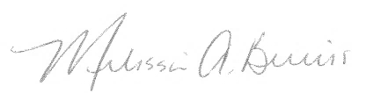

Melissa A. Burris

Regulatory Analyst

Enclosures