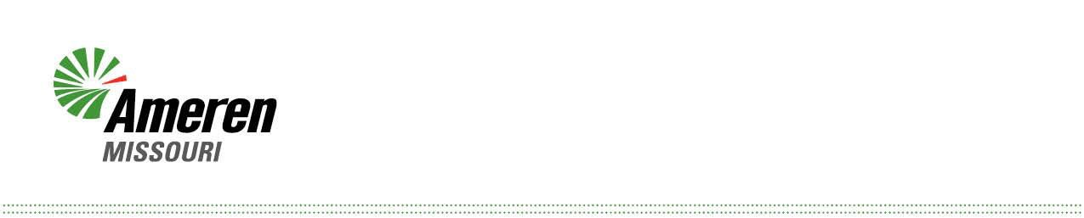

August 29, 2025

Ms. Nancy Dippell

Secretary

Missouri Public Service Commission 200 Madison Street, Suite 100

P.O. Box 360

Jefferson City, MO 65102-0360 Dear Ms. Dippell:

The accompanying tariff sheet issued by Union Electric Company d/b/a Ameren Missouri (Ameren Missouri or Company), is being transmitted for filing as 6th Revised Sheet No. 90.4, which is part of Schedule No. 6, Schedule of Rates for Electric Service, and will supersede the 5th Revised Sheet No. 90.4.

This tariff sheet is being issued August 29, 2025 to become effective on and after

October 1, 2025.

This sheet includes changes to the Company's Securitized Utility Tariff Rider (SUR), as approved by the Commission in Docket No. EF-2024-0021, in order to accommodate a True-Up and incorporate revised SUR calculations.

Sincerely,

**/s/ Wendy K. Tatro**

Wendy K. Tatro

Enclosure

Cc: Counsel of Record